Guidance document for submitting applications for the DSO/TSO Technopedia platform

ENTSO-E & DSO Entity
March 2026

Disclaimer
The content of this document is valid for the 2026 publication cycle and may be subject to further refinement in 2027 and beyond. Amendments are expected through a trial-and-test approach, aimed at making the DSO/TSO Technopedia an effective platform for sharing grid technology knowledge.

Table of Contents
Disclaimer 2
1 Background and scope 4
2 Application guidelines 4
2.1 Time window to submit applications 5
2.2 How to submit applications 5
2.3 Criteria for submission 5
2.4 Terms and Conditions 6
3 Application form 6
4 Technology list 6
DSO- and TSO-relevant technologies 6
DSO-only relevant technologies Error! Bookmark not defined.
5 Review process 6
6 2025 Timeline to publication 7

Background and scope
In October 2023, the European Commission published the Action Plan for Grids (COM/2023/757), a strategic document aimed at developing and strengthening Europe’s electricity grids to support the energy transition. As part of this initiative, DSO Entity and ENTSO-E (hereafter “the associations”) have been jointly tasked with showing technologies applied in the electricity transmission and/or distribution system that can improve the efficiency, stability, security, and resilience of the electricity grid.
To fulfil this task, the associations established a collaborative knowledge-sharing platform focused on technologies applied in the European grid (EU member states for DSOs, and represented countries by ENTSO-E for TSOs) and, in particular, their use cases for distribution and transmission system operators (SOs). While the platform emphasises the SO perspective, it also allows stakeholders to contribute valuable information in a collaborative manner for publication on the platform. Throughout the development of this platform, the associations act as moderators and facilitators, ensuring the SO focus is upheld while maintaining the quality and accuracy of the published information with the support of the stakeholders.
The associations launched the first iteration of the DSO/TSO Technopedia in 2025 with the intention to define a transparent application and review process that allows all stakeholders to collaboratively gather and publish the most relevant information on grid technologies on a single comprehensive platform. By using the first iteration of the DSO/TSO Technopedia as a baseline, the associations will continue this transparent approach to encourage the submission of valuable insights from technology providers, policymakers, and the broader public, while ensuring the platform remains inclusive, non-discriminatory, and representative.

Application guidelines
As briefly mentioned, in addition to the use cases provided by the associations, the platform will also accept stakeholder applications to publish use cases on specific technologies. The associations will thoroughly review each application to verify its validity for publication. Therefore, submission does not guarantee publication.

Figure 1: Process for publishing technology use cases from external stakeholders in the DSO/TSO Technopedia

Time window to submit applications
One publication cycle is planned per calendar year. The submission window for 2026 will be open from 1 April to 31 May 2026. Applications submitted after the deadline will be automatically excluded from the current review process. These applications can be revisited for the following Technopedia cycles upon assessing its relevance.
The relevance of submissions will be subject to DSO Entity and ENTSO-E perspective. Discussions with stakeholders regarding late submissions will happen before the selection of technologies for the next cycle.

How to submit applications
All applications must be submitted via the dedicated application form (TSO DSO Technopedia - Submit Application). Further details on the application form are provided in paragraph 3.

Criteria for submission
Applications may only be submitted for use cases in the European grid that relate to technologies falling within the platform’s defined scope. The list of eligible technologies for 2026 is provided below and available on the DSO/TSO Technopedia website (TSO DSO Technopedia - Guidance).
Any use cases involving off-topic technologies will be automatically excluded from the review process. Applications focused on specific technology components that are necessary but insufficient to achieve the full technological function will also be excluded.
Criteria for submission:
- Applications must relate to use cases within the European grid (EU member states for DSOs and represented countries by ENTSO-E for TSOs) and involve technologies listed in paragraph 4.
- Applications must be submitted jointly by the stakeholder and at least one SO.
- All applications must comply with the templates provided –answering all guiding questions - and the word count stated in the guidelines.
  - The results and benefits of the use cases must be clearly stated.
  - The descriptions of results and benefits must be objective and supported by measured evidence.
- Stakeholders – in cooperation with SOs – can also submit information about the general technology description, although it will only be treated as input material for the general technology description. The final generic description of each technology will be written and agreed upon by the associations.
- The use case must be specific and clearly connected to one technology.
- The use case must concern the overall technology and not a component that is necessary but insufficient to achieve the overall technological function.
- The specific maturity level must be described according to the TRL guidelines.
- Submitted use cases must fall in TRL levels 5–9 as described in the TRL guidelines in point 7.
The associations will review all submitted applications that comply with the submission criteria. If the associations approve the application during the review process, the technology use case will be published according to the review process guidelines as described in paragraph 5.

Terms and Conditions
By submitting content via this application form, the submitter confirms having read and agreed to the Terms and Conditions (available here). The submitter provides consent to the moderators (the associations) to review the content and publish it on the DSO/TSO Technopedia platform.

Application form
Applications by stakeholders must be submitted by uploading the application form in .doc or .docx format in the dedicated space (TSO DSO Technopedia - Submit Application).
The application form is split into three sections:
- Contact information: including information on the submitters.
- Generic technology template: providing a general overview of the technology and answering all guiding questions in each section
- DSO and/or TSO use cases template: showcasing concrete implementation for the specified technology in the distribution and/or transmission system answering all guiding questions in each section.
Submitting a general description of the technology is optional.
If provided, images and figures must include references to the original sources to prevent copyright infringement.
If submitting multiple use cases, one application per use case shall be submitted.

Technology list
The list of technologies for the 2026 cycle are:
- Forecasting Technologies for Demand and RES production
- Fault Current Limiter
- HVDC Circuit Breakers
- Phase Shifting Transformer
- Synchronous Condenser
- STATCOM
- Grid Forming Inverters
- Variable Shunt Reactors
- Dynamic Transformer Rating and Load Management
- Explicit Demand Response
- Wide Area Monitoring Systems
- Smart Meters
Further additions to this list will be communicated before the opening of the submission window.

Review process
Following the submission window, the associations will conduct a thorough and transparent review of all applications. Each association will limit its review to topics within its own scope of expertise (DSO Entity to review DSO-relevant technologies and use cases; ENTSO-E to review TSO-relevant technologies and use cases). A detailed overview of the division of responsibilities for the review process is provided in Figure 2.
The review process is structured in three phases:
- First screening: applications that do not comply with the criteria for submission, as described in paragraph 2.3, will be automatically excluded from the following steps of the review process.
- Thorough content review: submitted content will be reviewed by experts of the associations. If substantial changes to the content of technology use cases are required, submitters will be notified and asked to agree on the amendments.
- Content approval: prior to publication, the content shall be approved by the associations’ designated bodies.
Figure 2 outlines the review process, identifying the responsible parties for each step and differentiating based on application content and relevance.
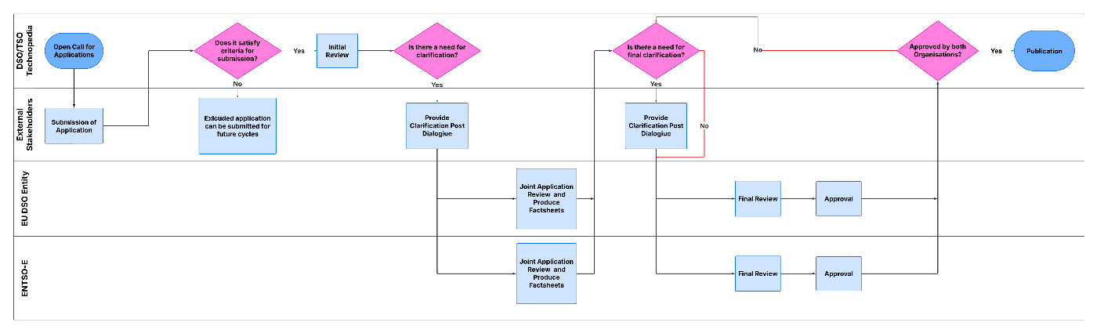
Figure 2: Flowchart of the DSO/TSO Technopedia review process – first screening in yellow, thorough content review in orange, and content approval in blue

For incomplete or defective applications, the associations may complete and adjust descriptions to ensure they are suitable for publication. This can also be achieved by merging different submitted materials or selecting the most relevant applications from multiple applications involving the same technology. Major changes will only be undertaken with the consent of the submitters. Rewording without substantially changing the content shall not be considered a major change.
The purpose of publishing existing technology use cases is to demonstrate how technology implementations in real-world operational environments can benefit the system, as described in the EU Action Plan for Grids. Applications with commercial promotional intentions will not be published.

2026 Timeline to publication
The planned timeline for the submission window and review process for publication is provided below.
- Submission window: 1 April 2026–31 May 2026
- First screening: June 1 2026 – 30 June 2026
- Review period: 1 July 2026–15 November 2026
- Publication and stakeholder engagement events: December 2026

EU Action plan for Grids: EUR-Lex - 52023DC0757 - EN - EUR-Lex

