ERAA 2026
Dataset EXPLANATORY NOTE
Call-for-evidence | 13 February 2026

ENTSO-E Mission Statement
Who we are
ENTSO-E, the European Network of Transmission System Operators for Electricity, is the association for the cooperation of the European transmission system operators (TSOs). The 40 member TSOs, representing 36 countries, are responsible for the secure and coordinated operation of Europe’s electricity system, the largest interconnected electrical grid in the world. In addition to its core, historical role in technical cooperation, ENTSO-E is also the common voice of TSOs.
ENTSO-E brings together the unique expertise of TSOs for the benefit of European citizens by keeping the lights on, enabling the energy transition, and promoting the completion and optimal functioning of the internal electricity market, including via the fulfilment of the mandates given to ENTSO-E based on EU legislation.
Our mission
ENTSO-E and its members, as the European TSO community, fulfil a common mission: Ensuring the security of the inter-connected power system in all time frames at pan-European level and the optimal functioning and development of the European interconnected electricity markets, while enabling the integration of electricity generated from renewable energy sources and of emerging technologies.
Our vision
ENTSO-E plays a central role in enabling Europe to become the first climate-neutral continent by 2050 by creating a system that is secure, sustainable and affordable, and that integrates the expected amount of renewable energy, thereby offering an essential contribution to the European Green Deal. This endeavour requires sector integration and close cooperation among all actors.
Europe is moving towards a sustainable, digitalised, integrated and electrified energy system with a combination of centralised and distributed resources. ENTSO-E acts to ensure that this energy system keeps consumers at its centre and is operated and developed with climate objectives and social welfare in mind.
ENTSO-E is committed to use its unique expertise and system-wide view – supported by a responsibility to maintain the system’s security – to deliver a comprehensive roadmap of how a climate-neutral Europe looks.
Our values
ENTSO-E acts in solidarity as a community of TSOs united by a shared responsibility.
As the professional association of independent and neutral regulated entities acting under a clear legal mandate, ENTSO-E serves the interests of society by optimising social welfare in its dimensions of safety, economy, environment, and performance.
ENTSO-E is committed to working with the highest technical rigour as well as developing sustainable and innovative responses to prepare for the future and overcoming the challenges of keeping the power system secure in a climate-neutral Europe. In all its activities, ENTSO-E acts with transparency and in a trustworthy dialogue with legislative and regulatory decision makers and stakeholders.
Our contributions
ENTSO-E supports the cooperation among its members at European and regional levels. Over the past decades, TSOs have undertaken initiatives to increase their cooperation in network planning, operation and market integration, thereby successfully contributing to meeting EU climate and energy targets.
To carry out its legally mandated tasks, ENTSO-E’s key responsibilities include the following:
› Development and implementation of standards, network codes, platforms and tools to ensure secure system and market operation as well as integration of renewable energy;
› Assessment of the adequacy of the system in different timeframes;
› Coordination of the planning and development of infrastructures at the European level (Ten-Year Network Development Plans, TYNDPs);
› Coordination of research, development and innovation activities of TSOs;
› Development of platforms to enable the transparent sharing of data with market participants.
ENTSO-E supports its members in the implementation and monitoring of the agreed common rules.
ENTSO-E is the common voice of European TSOs and provides expert contributions and a constructive view to energy debates to support policymakers in making informed decisions.
Table of Contents
Introduction 4
Geographical configuration and market coupling 7
Supply Capacities 8
Demand Forecasting Toolbox (DFT) 9
Implicit Demand Side Response (iDSR) 10
Additional consumption dispatch 11
Pan-European Climate Database (PECD) 12
[work in progress] Flow-based domains 12
Flow-based domains descriptive metrics 12
(partial data) Economic and technical investment parameters 13

Introduction
Data is initially collected from TSOs. After call-for-evidence, data will be amended based on stakeholders’ feedback collected and even further scrutinised by ERAA modellers. The data will remain preliminary until final ERAA publication date even if it is considered rather mature.
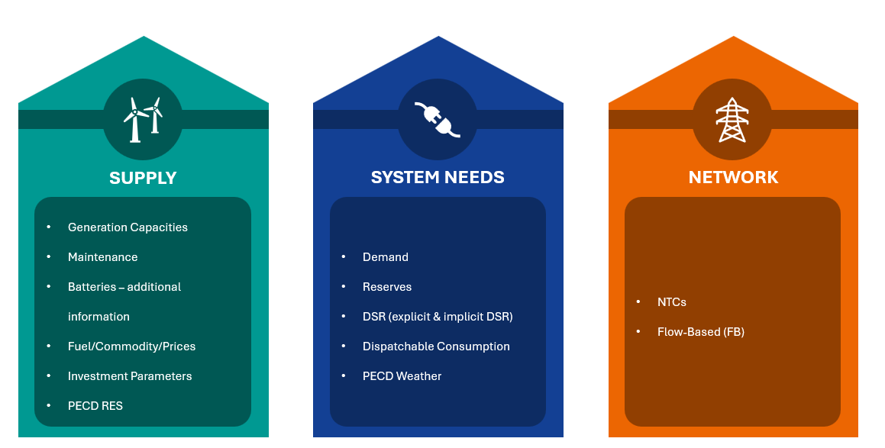
Figure 1 | Three main pillars of ERAA data input
The data for ERAA 2026 is collected for two scenarios: National Plans (NP) and Trends and Projections (TP). Both scenario datasets are denoted within the datasets. For more information about those, you may refer to the data collection guidelines.
The following list includes all data input files, which have been further grouped in three categories (Supply – System Needs – Network) as visualised in Figure 1. Dashboard - raw data (folder): This folder contains key data helping to interpret data used in ERAA 2026. Some of the files contain the detailed data (E.g. generation capacities.csv), while other files contain descriptive data (e.g. aggregated_demand.csv contains statistical information about demand time series, which are also published in respective folder).
  - Aggregated_Demand.csv: Descriptive data of how the electricity demand will evolve until 2035 – estimated as demand (TWh) per geographical area. This data is derived from the Gross Demand data in Demand folder (c.f. below item under complementary data).
  - Commodity Prices.csv: How will fuel and commodity prices evolve until 2035 – estimated as prices per blend.
  - [data is in preparation] Flow-Based_Core_KPI.csv: Descriptive data of the FB domains (c.f. below item under complementary data). It presents how will potential electricity exchanges capability evolve until 2035 in the Core Capacity calculation region – estimated as import and export capability (MW) per study zone permitted by FB domains.
  - GenerationCapacities.csv: How will domestic supply capacities evolve until 2035 – estimated as capacities (MW) per technology. The supply capacities include also explicit DSR capacities which could be dispatched in the models. This considers only known information about system development over coming years and is used as starting point in Economic Viability Assessment which results will be published in ERAA 2026 report.
    - [data is in preparation] MaintenanceDaily_PerTechnology.csv: How are maintenance and other planned unavailability distributed over each specific target year until 2035 – estimated as a combination of TSO data and the result of a ERAA central maintenance optimization.
  - Batteries additional information.csv: How will additional properties of batteries evolve until 2035. Charging capacity (MW). Storage capacities estimated as capacities (MWh).).
  - Hydro additional information.csv: How will additional properties of hydro capacities evolve until 2035. Pumping capacities (MW) per technology (Reservoir, Run-of-river, Open loop, Closed loop, and Pondage) and study zone. Storage capacities in (TWh).
  - Reserves requirements.csv: How will balancing reserves requirements evolve until 2035 to ensure system stability – estimated as balancing reserves (MW) per type (FCR/FRR), per technology (RES/thermal), and per geographical area.
- Complementary data:
  - Common data (folder): default characteristics regarding the different thermal generation technologies; among others fuel efficiency, CO2 emission factor, variable O&M cost, forced unavailability rates; and planned unavailability rates, which are used in maintenance optimization given in “ MaintenanceDaily_PerTechnology.csv”.
  - Demand Data (folder): various files containing data for each target year per country: gross demand, demand segments (electric vehicles and heat pumps parts), and PV-battery system additions.
    - Demand timeseries (folder): files containing data for each target year per country the gross demand.
    - Detailed demand (folder): various files containing data for each target year per country the demand segments (electric vehicles and heat pumps parts)
    - Behind the meter PV-Battery system additions: various files containing data for each target year per country subject to the BTM module the PV-battery system
    - IDSR ratios.csv: percentage ratios estimated of each flexible demand side element which is expected to be market-price responsive. Data is presented for each target year per study zone. C.f. Implicit Demand Side Response (iDSR) section below for more detailed explanation.
    - Additional dispatchable consumption.csv: it contains capacities of additional dispatchable consumption of electrolysers and power-to-heat (P2H). C.f. section below on “Additional consumption dispatch”.
  - [partial data] Economic and Technical Investment Parameters (CONE folder): relevant parameters used to assess viability of new investments or extraordinary measures on existing generation units (mothballing – de-mothballing; and life extension).
  - [data is in preparation] FB Domains (folder): domains calculated for CORE and Nordic capacity calculation regions.
  - NTCs (folder): How will interconnection capacities evolve until 2035 – timeseries of NTCs on each border and reported individually per interconnection technology (HVAC or HVDC).
    - Exchanges with non-explicitly modelled zones include a dedicated timeseries of assumed exchanges (MWh) with systems which are not explicitly modelled (with all the countries outside the ENTSO-E region).
  - PECD – RES (folder): package describing RES generation and hydro inflow estimate in each of the assessed hour in ERAA study and for all assessed Weather Scenarios, which are coherent with the ones given in PECD – weather folder.
  - PECD – Weather (folder): package describing weather conditions under each Weather Scenario in each of the assessed hour of ERAA study. This package was used for Demand Forecasting activities.

Geographical configuration and market coupling
The geographical configuration adopted in the ERAA 2026 is illustrated in . The list of Study Zones are elaborated in . The study zones have been encoded as follows: the alpha-2 ISO 3166 codes of each country, followed by a two symbol code to indicate if there are multiple study zones per country. The second part of the study zone code could also be related to geographical directions or other variables. Study zones which are offshore are highlighted in grey in . Those study zones have an explicit offshore areas mainly with offshore wind generation which in the models are connected via interconnectors to onshore study zones or even in between themselves. Nevertheless, some other onshore study zones may have offshore wind generation which are in the models connected directly to the onshore study zone and does not have an explicit offshore zone. In such cases offshore generation capacity is reported under the same onshore study zone. In any case wind load factor time series of both cases can be found in PECD – RES offshore package under respective study zones.
Although the NTCs are published, NTCs between study zones within Core Capacity Calculation Region are not used because flow-based domains are being applied for Core CCR in both: adequacy and economic viability assessment (EVA) simulations. Nevertheless, data was consolidated to be available as fallback solution if flow-based modelling would face difficulties and hence for information purposes we are publishing this data. Equivalent is valid for Nordic CCR.

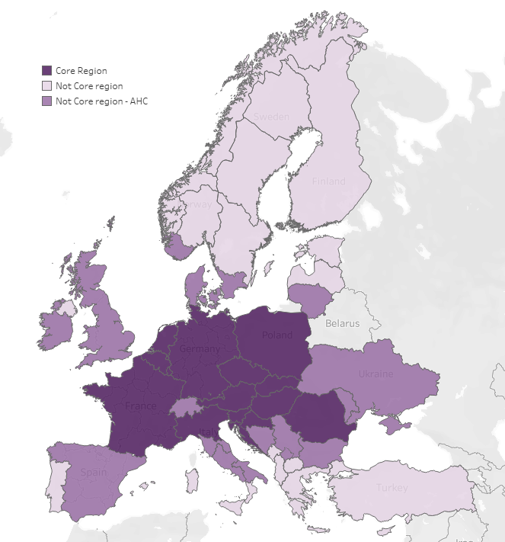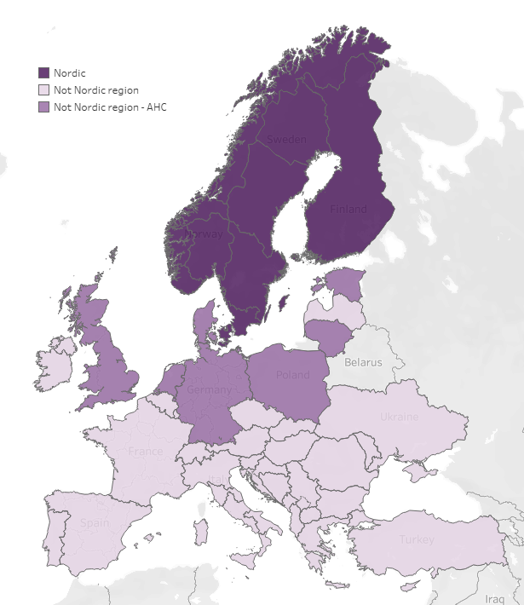
Figure 2 | Core (left) and Nordic (right) Flow-Based market coupling region
List of Study Zones
AL00 | DEKF | EE00 | ITCA | LT00 | NL0x⁵ | PLI0⁶ | SK00
AT00 | DE01 | ES00 | ITCN | LUG1 | NLLL | PT00 | TR00
BA00 | DKB2 | FI00 | ITCO | LUV1 | NOM1 | RO00 | UA00
BE00 | DKBH | FR00 | ITCS | LV00 | NON1 | RS00 | UKNI
BG00 | DKE1 | GR00 | ITN1 | MD00 | NOS1 | SE01 | UK00
CH00 | DKHE | GR03 | ITSI | ME00 | NOS2 | SE02
CY00 | DKKx | HR00 | ITVI⁶ | MK00 | NOS3 | SE03
CZ00 | DKNx⁵ | HU00 | ITS1 | MT00 | PL00 | SE04
DE00 | DKW1 | IE00 | ITSA | NL00 | PLE0⁶ | SI00

Legend: |  | Offshore study zones | Core FB Region | Other regions (NTCs)
 |  | Onshore study zones | Nordic FB Region
Table 1 | List of study zones, where those marked in grey are offshore

Supply Capacities
Reported generation capacities are further reduced to account for maintenance (according to published dataset, c.f. MaintenanceDaily_PerTechnology.csv) and further to account for deratings and eventually by forced outages (c.f. Common Data folder) simulated in the models, as referred to in Sections 10.7 and 10.8 of Annex 2 on the ERAA 2025 Methodology.
Furthermore, please note that capacities are considered respecting their operational status.
- Available on market: considered in ERAA.
- Inelastic supply / fixed profile: considered in ERAA.
- Mothballed: considered for de-mothballing decision in EVA and accordingly to EVA then in adequacy assessment..
- Out of market - for PV/battery dispatch optimization: considered in the assessment. It corresponds to residential PV and battery systems. C.f. “Implicit Demand Side Response” section below.
- Out of market - primary purpose resource adequacy (approved and contracted): considered as out of market resource to address adequacy risks but not influencing market pricing.
- Out of market - primary purpose resource adequacy (not yet approved and contracted): excluded from assessment.
- Out of market - primary purpose ancillary service: excluded from assessment.
- Out of market - primary purpose other operational activities: excluded from assessment.

Demand Forecasting Toolbox (DFT)
Hourly demand profiles are created using temperature regression and load projection model that incorporates uncertainty analysis under various climate conditions. The model comes in a software application (DFT) developed by an external provider and is used for most of the study zones. Meanwhile some TSOs provide their own demand time-series to be used by in ERAA, using their own demand forecasting tool, yet considering the common dataset of weather conditions found in PECD-weather package.
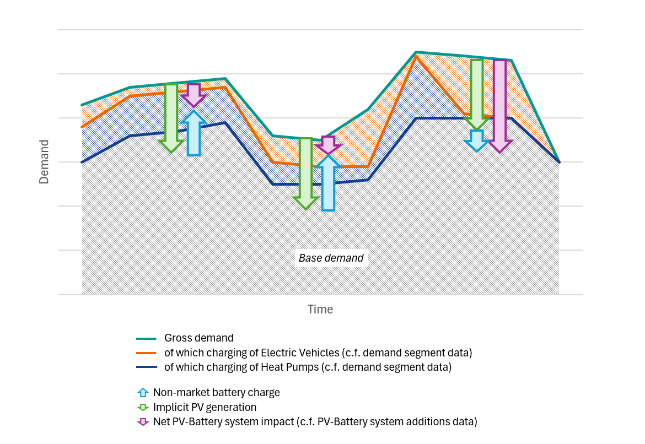
Figure 3 | Gross demand segments
Net demand could be considered as Gross demand lessen by the net PV/Battery impact if no implicit Demand Side Response (iDSR) reaction is considered; nor charging of batteries or hydro pumping; nor other large scale renewable generation. The PV/Battery impact is explained in the following section on iDSR; while large scale renewable generation is explicitly considered to supply net demand in the models. Charging of batteries and hydro pumping is optimized in the models and is not considered under gross consumption.

Implicit Demand Side Response (iDSR)
Implicit DSR (iDSR) is modelled to represent expected flexibility in European power system of Heat Pumps, Electric Vehicle (EV) charging and household battery-PV systems dispatch to adapt their pre-defined dispatch in time (reschedule). This is described in Section 2.3 and Appendix 2 of Annex 2 on the ERAA 2026 Methodology.
In general, EVs’ charging and HPs’ operation are exogenously accounted for in the gross demand profiles. Furthermore, implicit PV-Battery system dispatch is also pre-defined exogenously. Then the price sensitive part of each of those technologies (i.e. part which is expected to respond to the electricity prices after the market is cleared) is identified and modelled as available flexible resources capable to be rescheduled. Meanwhile the remaining part of those technologies (price non-sensitive) is kept in the models as part of the load profiles. Those price sensitive ratios are estimated by TSOs and are available in the iDSR ratio data packages.
Charging and discharging capacity and storage size available for flexibility is also based on price responsiveness ratio (c.f. iDSR ratios data package). As for the batteries properties, Discharging capacities in GenerationCapacities.csv and Charging and Storage in Batteries additional information.csv
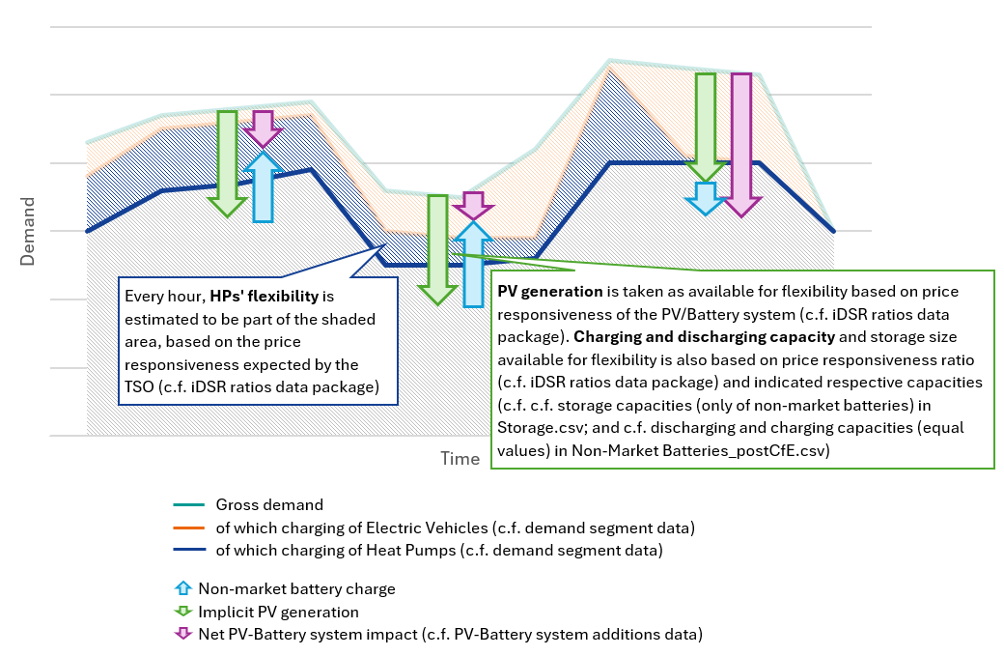
Household PV-battery system operation is reported individually for PV generation and battery dispatch operation. Net impact could be identified by netting those system operation. Flexibility of those systems are defined by iDSR ratio of battery systems. For that proportion of battery system, pre-defined dispatch can be re-optimized.
Figure 4 | Implicit DSR

Additional consumption dispatch
Some additional consumption could be dispatched in the models which refer to the expected electrolysers and Power-to-Heat assets (P2H) in the European system. The dispatch of this additional consumption depends on the electricity price in the dispatch models: if the cleared price is below the P2X price threshold, the “buy offer” is taken and the consumption gets dispatched.
The consumption capacities of electrolysers and P2H units are reported in the Additional dispatchable consumption file. The method for electrolyser dispatch is described in Section 7 of Annex 2 on the ERAA 2025 Methodology.
The operation of storage resources (only market-based batteries and hydro storage) is optimised endogenously within model. This includes charging/pumping decisions which should be considered as additional consumptions which is storing energy for later dispatch (used as supply). The storage sizes are reported in Storage.csv file; supply capacities can be found in Generation.csv file; charging capacity for batteries is equal to the supply capacity in Generation.csv file; pumping/charging capacities for hydro plants can be found in Hydro capacities.csv.

Pan-European Climate Database (PECD)
This database describes renewable generation estimates (or hydro inflows for dispatch) for each of the Weather Scenarios (WS) used in ERAA 2026 study. It also contains weather variable used in DFT or by TSOs in their own demand forecasting tool. Please refer to the PECD documentation here.
The PECD data disclosed comes in part from the PECD4.1 dataset developed by ECMWF, C3S and ENTSO-E under a CC-BY-4.0 licence. The PECD4.1 dataset will be made publicly available in the coming months via the Copernicus Climate Data Store (CDS).
Nevertheless, Hydro constraints (package within PECD RES package) were provided by the TSOs individually.
The data is based on three climate models (CMCC-CM2-SR5 (CMR5); EC-Earth3 (ECE3); MPI-ESM1-2-HR (MEHR)) and based on specific calendar year assessed in the climatic models. Specific mapping between Weather Scenario labels used in ERAA and those specific models and calendar years can be found in dedicated mapping file (“Weather Scenarios_Mapping” within PECD-weather data package).

[work in progress] Flow-based domains
Each FB domain within a FB domain set for a particular target year is defined by Flow Based domain ID (FB ID) identified. It consists of set of PTDFs for a number of CNECs, set of RAMs for respective CNECs. PTDFs and RAMs are stored in their own sheets and they can be linked respecting the FB ID and CNEC IDs. In particular FB domain within example of “Full Core” domain set you can refer to the six domains per target year. Furthermore, a timeseries of FB IDs are given in “FB Domain Assignment” sheet to list which domains are used in which simulation timestep for each of the assessed weather scenarios.
Please refer to the Section 4 of Annex 2 on the ERAA 2025 for more information about FB domain concept and computation methodology. Refer to FB_Readme.xslx (“Lin. Constr. Representation” sheet) for a mathematical market coupling formulation.
Please note that a single set of CORE FB domains will be prepared for ERAA 2026. FB domain simplifications as in previous ERAAs are expected to be not required.

Flow-based domains descriptive metrics
Descriptive metrics are given in FB Key Performance Indicator (KPI) files. Those include maximum import and maximum export capabilities of study zones within the Core FB CCRs. Since Core FB domains contain only handful of typical FB domains this property is computed for each of the FB domains and published along the FB domains themselves (c.f. FlowBased_Core_KPI files).
Descriptive metrics are typically computed either to estimate potential import or export capacity from within given CCR (e.g. Core; and disregarding exchange capacities with other regions outside specific CCR) or to consider potential import (or export) capacity from within given CCR (e.g. Core) and neighbouring systems (e.g. Spain for Core region). The former descriptive metrics are distinguished with “No AHC” labels suggesting that Advanced Hybrid Coupling (AHC) interconnectors are not considered in the descriptive metric calculations. The later are distinguished with “With AHC” labels suggesting that AHC interconnectors are considered.
No AHC metric computation region
Out of scope for descriptive metric computation
With AHC metric computation region
FBMC regions
Figure 5 | Exemplary ERAA 2023 region presentation for FB domain descriptive metric computation - Consideration and disregard of AHC region

(partial data) Economic and technical investment parameters
Various economic and technical investment parameters are relevant for EVA study along the fuel and commodity prices. Those values are present in Economic and technical investment parameter files (Economic and technical investment parameters folder).
- Economic and technical investment parameters_Default: this data is applied by default for in all study zones for thermal and battery investment candidates. For DSR investment candidates this is also applied for all study zones where no country specific data is available. This data was derived from country specific values (c.f. below).
- Economic and technical investment parameters_Country Specific: is applied for each specific study zone for which any relevant information is available if default data is not considered to be used across Europe. It also contains information about country specific values consolidated from national studies for information purposes (as presented in annexes of ERAA 2025). The source of data is indicated within files and it is in priority order: national study on Value of Lost Load (VoLL) or Cost of New Entry (CONE) to establish Reliability Standards; National study on the matter; Central ERAA estimate only applicable to some parameters (e.g. for DSR potential estimation). ERAA study re-utilizes economic and technical parameters which were defined for a use in respective national studies.
These parameters include:
- New investments:
  - Investment and operation related costs (respective CAPEX, FOM and VOM sheets): Capital Expenditure (CAPEX), Fixed Operational and Maintenance costs (FOM) and variable operational and maintenance costs (VOM). These costs come in addition to the fuel and CO2 credit costs needed for the dispatch if units are built.
    - DSR investments is complemented by additional economic and technical information: DSR activation price (given in “DSR Activation Price” sheet) and DSR activation limits (given in “Activation Limit” sheet). Former is important as DSR is not driven by fuel, but rather relies on the reduction of consumption, which in turn has its own cost. Latter is important as DSR can typically be used for a limited amount of time per day.
  - Default values are derived from set of country specific values and then used for all study zones for OCGT, CCGT and Hydrogen plants. Country specific battery CAPEX, VOM, FOM are published for transparency as consolidated from national Cost of New Entry studies.
  - [Work in progress] Potential capacity of investment (Potential sheet): is limitation for a given system to accommodate new investments builds in specific target year. Value of 2035 suggest the total investments by that target year (in any of the target year). Value of prior years should be considered as part of 2035 investments allowed by a given target year (e.g. by 2028). Example: if investment is limited to 3 GW by 2028 and to 5 GW in 2035, then total investment over studied period cannot exceed 5GW while investments until 2028 end of the year cannot exceed 3GW. However, if 3 GW investments are not commissioned by 2028 (e.g. only 2 GW are commissioned), then remaining investment potential (1GW) could be commissioned in the following years respecting the total investment potential of 5GW by 2035.
  - Economic lifetime (“Economic Lifetime” sheet) suggests the time period under which investments are planned to be operational and should recover investment costs.
- [work in progress] Mothballing units:
  - Cost to mothball units (“Mothballing FOM” sheet) indicates annual costs to keep units mothballed without decommissioning. Such units are available to be de-mothballed if it becomes profitable.
  - Cost to de-mothball units (“De-Mothballing_Cost” sheet) indicates Capital Expenditure costs needed to return generating unit to operations from mothballed state.
- [work in progress] Lifetime extension
  - Lifetime Extension Capital Expenditure costs (“LifeTime Extension” sheet) indicates one time expenditure needed to extend lifetime of a generating unit (i.e. cost for major overhaul).
  - Lifetime extension FOM (“LifeTime Extension_FOM” sheet) suggests expenditure needed to maintain unit in operating state after it’s life extension. Despite CAPEX, FOM remains relatively high in comparison with units whose economic lifetime has not expired.
- [work in progress] Investment margins
  - Investment expected margin thresholds are composed of Weighted Average Capital Cost (WACC; respective sheet) and Hurdle Premium (respective sheet).
For further reference about these properties you can refer to the Section 6 of Annex 1 of the ERAA 2025 Data Input and Sections 10.7 and 10.10 of Annex 2 of the ERAA 2025 Methodology for investment margin specific items. During call-for-evidence of ERAA 2026 dataset, ERAA 2026 report will be published and same information may be referred in equivalent sections of ERAA 2026 publication.

Exchange capability permitted by FB domains means only theoretical capability allowed by FB domains, which technically might be infeasible considering available generation in Core or Nordic study zones.
PV-battery system additions are reported separately for PV and battery dispatch. The positive values of battery part suggest discharging, while negative suggest charging. The respective battery and PV installed capacities under these profiles can be identified by finding respective technology capacities with operational status “Out of market – for PV/Battery optimization”.
Value is positive if the flow is a net import (i.e. the ENTSO-E member country imports. from the non-ENTSO-E neighbour) and negative if it is a net export
For a list of interconnections please refer to the published preliminary NTC file.
This is a virtual modelling hub used. Please refer to NTC data.
A number of zones are denoted with varying symbols behind x.
Meanwhile, PV farms and battery systems participating to market dispatch are modelled explicitly in the ERAA models. Those capacities can be found in Generation Capacity publication file as Large scale PV and Batteries’ capacity.
The graph is example from ERAA 2023. In ERAA 2026 only Ukraine part should be disregarded as it is not modelled. Meanwhile Switzerland and Northern Italy are now included in Core FBMC region, while Northern central Italian zone becomes AHC zone. Furthermore, some offshore zones (c.f. section 1 of this document) are also not visible in the map, but those are taken into account when computing descriptive metrics.
This national data is collected to show latest information. This is without prejudice to which parameters will be applied in ERAA 2026. Please refer to ERAA 2024 for more insights on the implications of diverging CONE values.

