Conference: Adaptation & Resilience
  - Ensuring the energy transition is built on resilient infrastructure
14 March | 11 am to 3:45 pm – Online

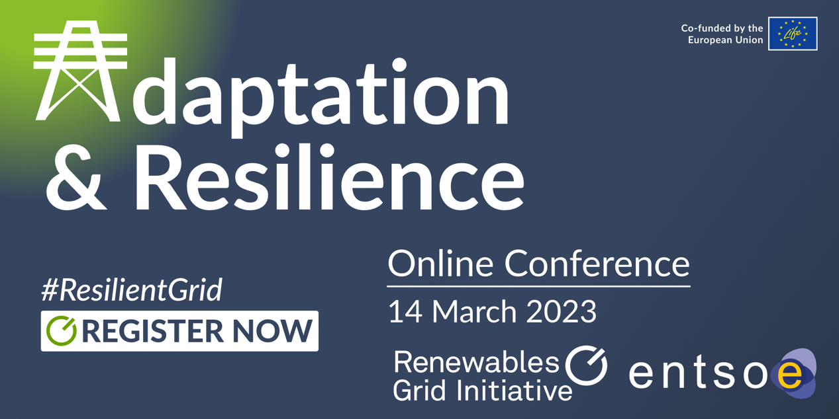

“Climate change directly affects every segment of the electricity system altering generation potential and efficiency, testing physical resilience of transmission and distribution networks, and changing demand patterns”. (IEA on climate resilience)

The conference ‘Adaptation & Resilience’ – jointly hosted by RGI and ENTSO-E will explore the effects climate change is having on our physical electricity infrastructure, as well as the additional impacts it is likely to have in the future. Is it resilient enough to withstand extreme weather events? How can we adapt it to the impacts of climate change? How will this effect energy infrastructure planning in the future?
Our conference is supposed to help answer these questions and kick-start a discussion on next steps by bringing the involved actors into one room and talk about the changes required to adjust to the realities of climate change when building the infrastructure for the energy transition.

Draft Agenda

Welcome and Setting the Scene
11:00 | - Antonella Battaglini, CEO | RGI  - Sonya Twohig, Secretary General | ENTSO-E
Keynote Session
11:15 | Expected impacts of climate change on energy infrastructure and its operation  Speaker:  Swenja Surminski, Professor in Practice - Adaptation Research | Grantham Research Institute on Climate Change and the Environment  - Covering impacts of long-term as well as extreme events
11:30 | Adaptation and resilience – Concepts and Definitions in the context of energy infrastructure  Speaker:  Malin Göteman, Senior Lecturer/Associate Professor | Department of Electrical Engineering, Uppsala University
Looking at the big picture – Key elements of an adaptive and resilient energy system
11:45 | Panel Discussion:  What are the key elements we need to consider when planning a robust and resilient renewable energy system?  Discussing physical threats to infrastructure, impacts that disrupt operation and threats of scarcity (resource, supply chain, work force)  Speakers:  - Alessia de Vita, Director | E3M  - Craig Hart, Energy Analyst – System Integration of Renewables Unit | IEA  - Louise Rullaud, Head of Distribution & Market Facilitation | Eurelectric  - Marcel Lenzin, Head of Grid Delivery | Swissgrid

LUNCH BREAK from 13:00 to 14:00
incl. Networking Lunch for Speakers

Embedding adaptation needs of energy infrastructure into modelling and planning processes
14:00 | Best Practices: Resilience measures: Discussing existing best practices  - ENTSO-E’s Pan-European climate database: the modelling perspective,  David Radu, System Development | ENTSO-E  - Terna’s Resilience Strategy: the TSO perspective  Silverio Casulli, Head of Grid Resilience and Security Planning | Terna  - E.ON's response to experiencing disastrous floods: the DSO perspective  Dr. Michael Wilch, Project Lead iNetz (Smartification) | E.ON
14:30 | Panel Discussion:  What is needed to successfully embed adaptation needs of energy infrastructure into modelling and planning processes?  - How do we include factors that could address current crises, like supply chain, resources and work force, into modelling?  - Is it possible to reflect these threats accurately? Why/not?  - What are the related regulatory challenges?  - What are the steps policymakers have to take now?  - Which points in the planning process are best take these questions into account?  - What is the role of DSOs? Which coordination is needed?  Speakers:  - Gerald Kaendler, System Development Committee Chair | ENTSO-E  - Dr. Wided Medjroubi, Group Leader | Institute of Networked Energy Systems, German Aerospace Center (DLR)  - Dr. Michael Wilch, Project Lead iNetz (Smartification) | E.ON  - Cosimo Tansini, Policy Officer for Renewable Energy, EEB
Wrap-up & Outlook
15:30 | - Antonella Battaglini, CEO | RGI  - Sonya Twohig, Secretary General | ENTSO-E

