LPIT
Approval Version| 23 October 2023

From: SOC / StGO / Protection Equipment SG

Table of contents
LPIT Approval Version| 23 October 2023 1
From: SOC / StGO / Protection Equipment SG 1
1. INTRODUCTION 6
2. What is a LOW POWER INSTRUMENT TRANSFORMER? 7
2.1. General design 7
2.1.1. Different sensor technologies: Some examples 8
2.1.2. Link option 11
2.1.3. Merging Unit output options 11
2.2. Synchronisation 12
2.3. Lifetime cycle 16
2.4. Standardisation 16
2.5. LPITs and metering for billing 18
2.6. References 20
3. Applications in Digital HV substations 22
3.1. LPITs in the fully digital substation 22
3.2. The basic steps of introducing digital technology 23
3.3. The pilot project in ČEPS,a.s. 23
3.4. RTE’s experience 29
4. TSOs questionnaire 32
4.1. Conventional Instrument transformer 33
4.2. Prerequisite for LPITs 38
4.3. Use of LPITs 41
4.4. LPIT Strategy 47
5. Conclusion 54

Definitions

IT: Instrument Transformer as defined by IEC [321-01-01]. A transformer intended to transmit an information signal to measuring instruments, meters and protective or control devices.

LPIT: Low Power Instrument Transformer as defined by IEC 61869. An IT intended to be connected to measuring instruments, meters and protective or control devices that requires low power (analog or Digital). The general design of an LPIT includes 3 elements: sensing, link and merging unit, as described in chapter 2.

FD-PACS: Fully Digital Protection and Control System. A protection and control system intended to receive a digital information signal from ITs.

SV: Sampled Value as defined by IEC 61850: Digital information format for transmit information from LPIT to FDPACS.

Other symbols and abbreviated terms
AC alternating current
ADC analogue-to-digital converter
AIS air-insulated switchgear
CS control system
CT current transformer
CVT capacitor voltage transformer
EIT electronic LPIT
EMC electromagnetic compatibility
GIS gas-insulated switchgear
GNNS global navigation satellite system
IED intelligent electronic device
IT instrument transformer
LPIT low-power instrument transformer
LPVT low-power voltage transformer
MU merging unit
NCIT former name for LPIT
NTP network time protocol
PACS protection automation and control system
PMU phasor measurement unit
PTP precision time protocol
SAMU stand-alone merging unit
TSO Transmission System Operator

Summary

The recent development of electronic relays combined with digitalisation technology has opened a path to designing new, fully digital smart substations using the IEC 61850 standard. Within this new paradigm, it is no longer necessary to use conventional instrument transformers (ITs): a low power instrument transformer (LPIT) can be used instead. An LPIT is composed of a high voltage part (sensor), a link and the merging unit (MU). All these items are described in this paper.
With the arrival of LPITs, time synchronisation accurate close to a microsecond is needed for the locators and protection aspect. Technologies such as travelling waves require even more precise synchronisation.
The lifetime cycle also presents a main challenge for LPITs as the electronic part of an LPIT does not have the same lifetime as the sensor.
A questionnaire was designed by the Protection Equipment Group to investigate the various experiences with LPITs and the advantages and drawbacks of using them. The main benefits of LPITs concern the environmental aspect, the safety and security aspects and the technical capacity (harmonic measurement, no saturation). The drawbacks concern principally the price of a LPIT, the complexity of this new system and the readiness of the supplier.

List of figures

Figure 1: parts of an LPIT (IEC 61869-6) [2] 8
Figure 2: Faraday sensor (Príncipe) 9
Figure 3: A rogowki coil 9
Figure 4 Pockels ceLl 10
Figure 5 : Electric sensor 10
Figure 6: LPIT (MU) Connection with 61850 process bus. 12
Figure 7: The system architecture for time synchronisation 14
Figure 8: Scheme of the WDM infrastructure 16
Figure 9 : 61850 substation model 22
Figure 10: The block scheme of the pilot project 24
Figure 11: Measurement of active power when time synchronisation is lost (11/17/2017-12/11/2017) 25
Figure 12: Current measurement in the same period (17.11.2017–11.12.2017) 26
Figure 13: Measurement from the inductive current transformer during a fault in L2 27
Figure 14: Measurement from the optical current transformer during the fault in L2 27
Figure 15: Instantaneous differential current values between the inductive and the optical current transformer 27

INTRODUCTION
Since the beginning of high voltage transmission, ITs have been required for measuring voltage or current flowing through lines or power transformers. They are essential actors for current and future power networks. They allow the insulated measurement of these electrical quantities, providing sufficient information for grid management, protection and control.
The current generation of ITs, also called conventional ITs, were designed decades ago to deliver a sufficient amount of power in order to trip the electromechanical protection relays. Nowadays, the development of electronic relays combined with digitalisation technology has opened a path to designing new, fully digital smart substations using the IEC 61850 standard. Within this new paradigm, it is no longer necessary to use conventional ITs delivering such output power, the (nonconventional) LPITs will be part of these new digital substations.
As it is no longer required to deliver such power, it is possible to use smaller sensors such as Rogowski coils, or the optical Faraday Effect. Due to the lower weight, they could be easier to transport and install, thus reducing costs. This sensor involves electronic parts, which leads to new challenges. These challenges must be specifically addressed.
A questionnaire was sent to all TSOs in 2021. The answers form the main basis of this document, the purpose of which is to share experiences with LPITs.

What is a LOW POWER INSTRUMENT TRANSFORMER?

General design
According to IEC 61869-6, an LPIT is composed of three parts: a HV Subassembly and an MU, linked together by a link with the following definitions. [2]
HV Subassembly 1: a ‘high voltage part’ intended to be installed in the switchgear area as described in figure below (applicable for air-insulated switch-gear [AIS] and also gas-insulated switchgear [GIS]).
MU: Merging Unit, see ‘Subassembly 2’ described in the figure below, is a physical device in which a logical device merging unit is implemented. The MU provides the proper output of the measured quantity in a form compatible with the control command system or application devices.
Link: Link between HV Subassembly and the MU.

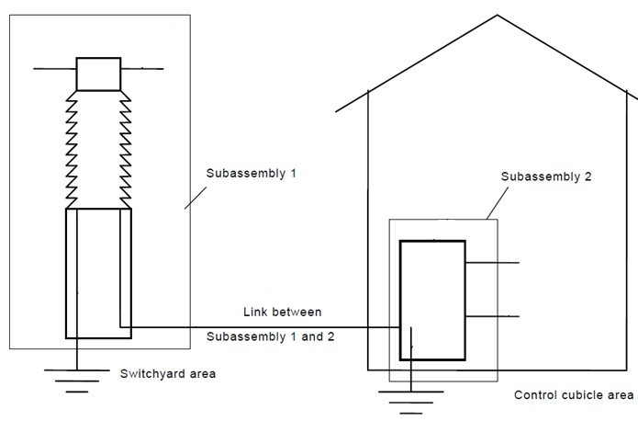
Figure 1: parts of an LPIT (IEC 61869-6) [2]

With this definition, the HV subassembly 1 contains sensor(s) to measure the electric quantity, i.e. Primary voltage or primary current.
The sub assembly 2 can be installed either in a relay room or in an outdoor kiosk.
PACS: Protection Automation and Control System.
FD-PACS: Fully Digital Protection Automation and Control System.

Different sensor technologies: Some examples
Using non-conventional technologies, Primary Sensors can be based on different ‘electro-physical’ principles. The purpose of this document is not to give an in-depth description of the sensors but to present the principles and the physical nature of the most common types of sensors used in LPITs. The following list is not extensive; other technologies can be used.

Current measurement.
For current measurement, the two following non-conventional sensors can be employed:

Optical Faraday sensor
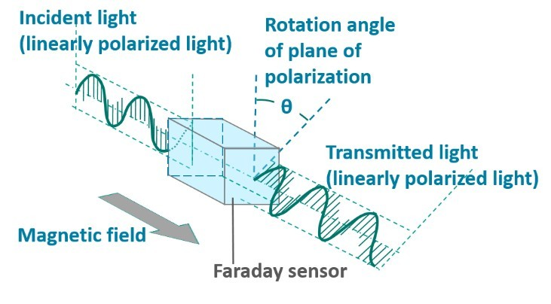
This sensor is based on the Faraday effect, which is a magnetic effect. When a piece of glass is placed under a magnetic field, the polarisation plane of the incident light rotates proportionally to the magnetic field.
Figure 2: Faraday sensor (Príncipe)
$$θ=k B$$
Then, if the sensor is designed to encircle the primary conductor, using the Ampère theorem it becomes the measure of the current via the following equation.
$$I= \frac{1}{μ_{0}}\oint{\overset{⃑}{B}}. \overset{⃑}{dl}$$
Furthermore, the appropriate material could be used as the sensor itself.
This kind of sensor can be designed with either a bulk of glass assembly or fibre optics (ref Kiyoshi KUROSAWA [17]).

Rogowski Coil sensor
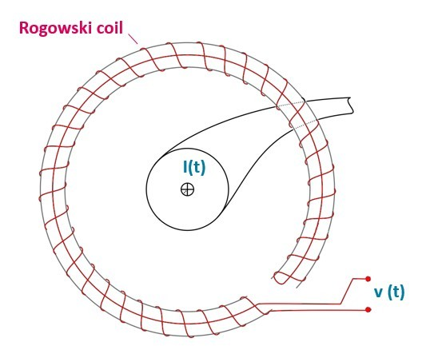
A Rogowski coil, named after Walter Rogowski, is an electrical device for measuring alternating current (AC) or high-speed current pulses. The Rogowski coil is based on the principle of a CT with a very high load impedance, where the ferro-magnetic core has been abandoned completely. It consists of a helical coil of wire, with the lead from one end returning through the centre of the coil to the other end, so that both terminals are at the same end of the coil (see Figure 3). With this sensor, the voltage that is induced in the coil is proportional to the first derivative of current in the straight conductor.
Figure 3: A rogowki coil
$$v\left(t\right)=k \frac{dI(t)}{dt}$$
Based on this formula, it is obvious that the Rogowski coil requires an electrical (or electronic) integrator complementary circuit to provide an output signal that is proportional to the current. [10]

Voltage measurement.
Optical Pockels Effect
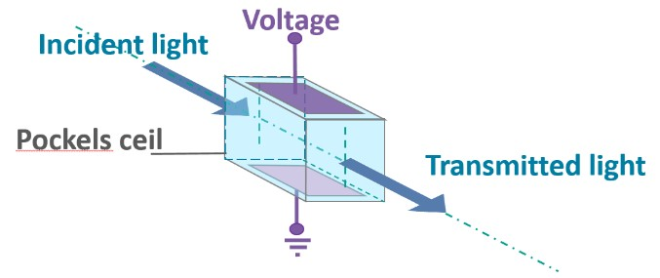
The sensor directly measures the electrical field strength between a high potential electrode and the ground electrode.
Figure 4 Pockels ceLl
The Pockels effect is a linear optical effect. It is an electric field induced linear birefringence in the refractive index of the material.
Then, the difference between two propagation polarisations can be calculated according to the following equation, where V is the applied voltage and V$π$ is the half-wave voltage.
$$δ=π \frac{V}{V_{π}}$$
Due to technical constraints and cost optimisation, HV application are required to reduce the primary voltage to a lower voltage level according to the manufacturer’s specification. [15]

Electric sensor
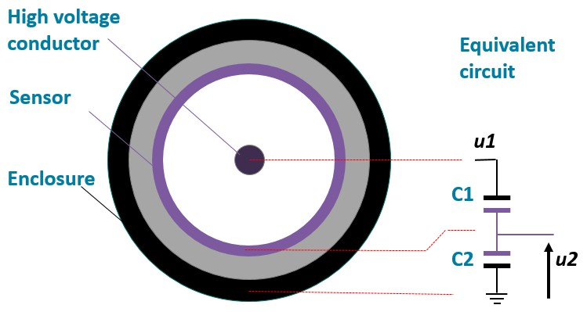
The design of an electric sensor or probe is very similar to the design of the capacitive divider. Due to the position of the sensor, a high voltage capacitor (C1) is created between the high voltage conductor and the sensor; in addition the capacitor C2 appears between the sensor and the grounded enclosure. Then secondary voltage is as follows:
Figure 5 : Electric sensor
$$u2=u1 \frac{C1}{C1+C2}$$
There are many designs that employ this principle. The drawing in Figure 5 is more convenient for ‘cable’ applications. Many variations are seen, for example, with the type of gas or solid material used to insulate the high voltage conductor and the sensor, as well as the insulation material used to build capacitor C2.
In electric field sensor applications, as in the drawing in Figure 5, a precision resistor is added parallel to C2. The impedance of the resistor is chosen to be much smaller than the capacitance between the electrode and the enclosure to cancel the capacitance’s drift. The output signal of the sensor is then proportional to the current through the high voltage capacitor, i.e. proportional to the first derivative of the primary voltage. [15]

Link option
The link between the subassembly 1 and the merging unit is a cable, which can be either copper or fibre optic. Fibre optic cables are more suitable for long distance applications and have a natural electric insulation, which increases the product’s safety level.
The fibre between the sensor winding and the measurement electronics can be long, which is an advantage in air-insulated switchgear, where the optic sensor is at high voltage potential and the fibre provides the necessary insulation for the connection to the control or relay cubicle. In GIS, fibre optic current sensors have been piloted in a few installations but are less attractive than Rogowski coils due to their higher cost and complexity. [11]

Merging Unit output options
The typical output for conventional ITs is analog 1A or 5A and ~ 100V per phase. With LPITs, the output of the MU can be:
- analog (Example: 0–10 mA per phase)
- digital using IEC 61850‑9‑2 and more specifically IEC 61869‑9 Sampled Value output.
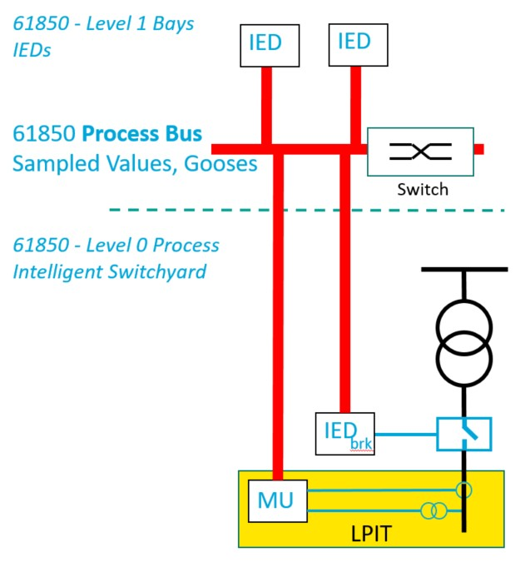
For fully digital substations, the output is a digital stream of continuously sampled values. Figure 6 shows the LPIT connected to the IEC 61850 Process Bus of a fully digital substation.
In a fully digital substation, the Sampled Values are delivered by the process bus to the intelligent electronic devices (IEDs). According to IEC 61850, the Process bus is located between the Process Intelligent Switchyard level (level 0) and the Bay level (level 1). The process bus also supports data exchanges between IEDs (Goose messages).
The process bus could be made with fibre optic cables to avoid electric influences problems.
To increase reliability, the MU could be equipped with redundant fibre optic connectors.
Figure 6: LPIT (MU) Connection with 61850 process bus.

Synchronisation
According to IEC 61850, a fully digital substation needs all sampled value data to be synchronised. In particular, functions using data from different LPITs require synchronisation to ensure functions work properly with the accuracy expected. The preferred synchronisation protocol, according to IEC 61869-9, is IEC 61588:2019 Precision Time Protocol (PTP, also known as 1588). The LPIT may also use a one pulse per second (1PPS) input as specified in the IEC 61869 standard instead of (or as an optional alternative to) PTP for legacy applications.
Time synchronisation has always been a fundamental requirement for the proper operation of the power system, but the time loss did not previously lead to the IEDs’ malfunction, and so the correct operation of PACS was ensured.
However, with the arrival of devices such as LPIT, the situation is beginning to change. For their proper operation, these devices need precise time synchronisation, with an accuracy close to microseconds. Furthermore, it is not only LPITs but also devices such as PMUs that necessarily require time synchronisation with this accuracy. Locators and protections based on the travelling wave principle requires time synchronisation with even higher accuracy.
The impact of the loss of time synchronisation depends on the technical solution of the system:
- If a protection gathers the SV stream from only one MU, the time synchronisation loss will not impact the substation’s protection.
- If the protection collects the SV streams from different MUs and the SVs are synchronised by an external clock, the synchronisation loss in the substation will result in protection failures.
- A similar situation occurs if a line differential protection synchronises the currents by an external clock; here, the time synchronisation loss between substations will cause the line differential protection failure.
Hence, it is necessary to provide reliable time synchronisation techniques for PACS. The clocks must be redundant. The clock’s reference signals should be redundantly configured and from distinct systems. The clock should also hold over for a specified period.
Nowadays, increasing numbers of devices require accurate time synchronisation. There are often numerous independent solutions for a wide range of applications, leading to inefficiencies, a higher risk of abuse, manipulation of the time resource, and attacks on systems of TSOs. The implementation of a unified centralised time synchronisation solution appears to be more advantageous, thereby increasing safety (independence on satellite time synchronisation in the event of failure/deliberate decommissioning by the global navigation satellite system [GNSS] operator); introducing standardisation (a unified concept that will unambiguously declare instructions for operation, maintenance or deploying new systems using time synchronisation); and increasing economic efficiency (use of a unified system and thus savings compared to the number of decentralised systems for time synchronisation including installed GNSS antennas, savings in maintenance).
The following describe a possible solution for the central distribution of the time signal. The emphasis is placed on technology location and optimisation for the PTP protocol, whereby the maximisation of time accuracy is required. Once the proposed architecture is implemented, it is possible to provide time services to selected networks also using the NTP protocol, and therefore it is possible to provide time synchronisation in many variants.
The topology in the following figure is deliberately targeted for maximum accuracy. It consists of several high-quality and accurate time sources at selected central locations and furthermore from a larger number of peripheral locations (substations), each of which has two time bases. The architecture is designed with the highest possible accuracy in peripheral locations in mind while ensuring sufficient redundancy. Time bases at substations can have outputs NTP, PTP and discrete signals common in energetics (IRIG, 1PPS). Peripheral locations have the option of using as a time source either local GNSS signal or time from central sources, spread by land route (optical network). Switching to a peripheral location can be done manually or automatically. The time base at the substation has several upstream time sources configured with a predetermined (configurable) priority order. The switch will occur if the current input reports quality deterioration / signal failure.
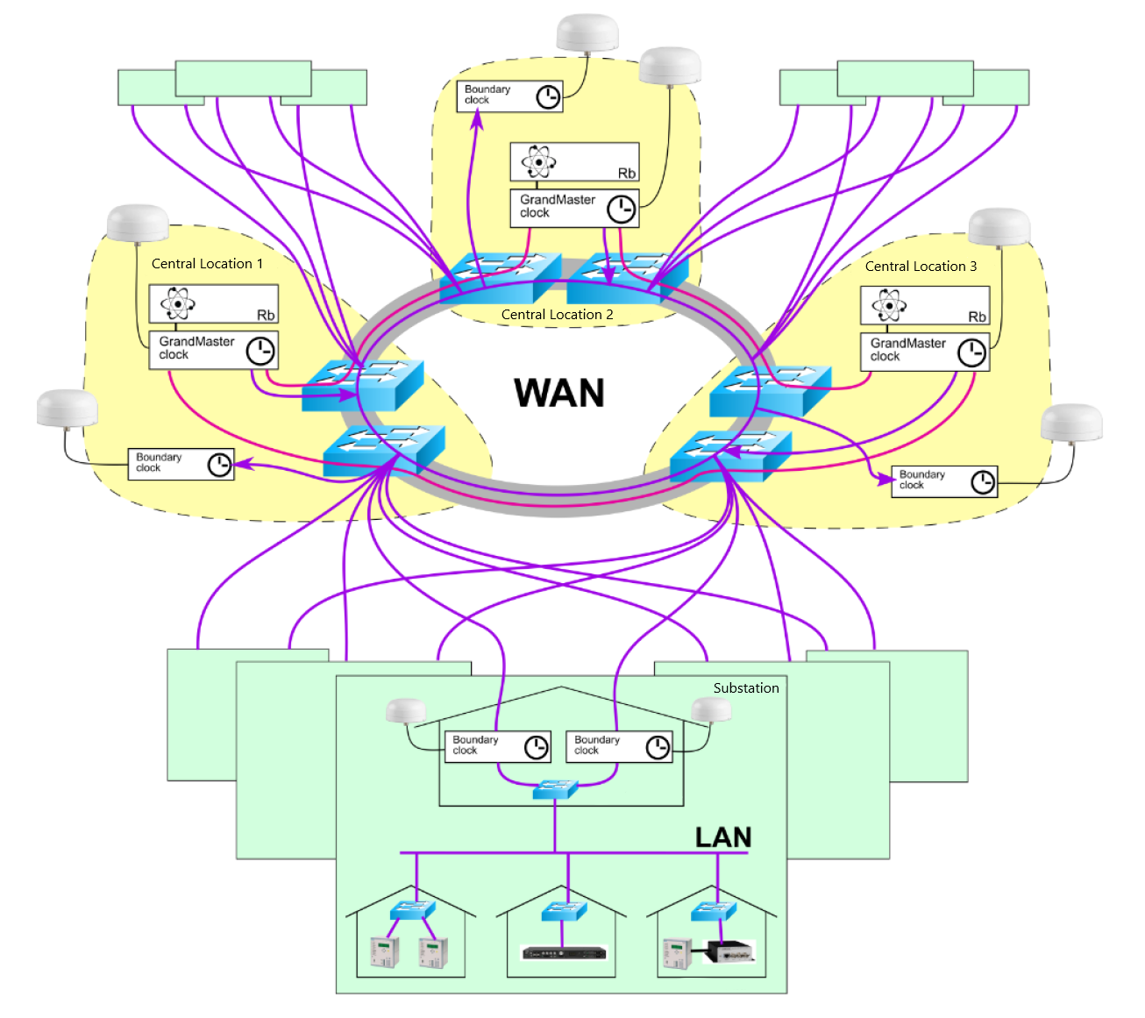
Figure 7: The system architecture for time synchronisation
A few basic recommendations can be made on the general principles of accurate time distribution:
- proceed in a cascade from accurate to less accurate sources;
- try for geographical and topological redundancy or use more sources; and
- according to experience from the Telco industry, a strict hierarchy of time resources is more appropriate on a WAN network, rather than an automatic calculation of who will be the master (according to IEEE1588).
The high availability of the time synchronisation service is a key requirement of users. For this reason, several measures that ensure high availability should be used in the design, e.g.:
- The central locations are connected in a circle into a PTP cluster, the so-called Group Clock, to increase the resistance of the GrandMaster Clock failure.
- GrandMaster Clocks are connected to different switches and simultaneously in the ring of multipath optical routes.
- There is an additional Boundary Clock in the central locations in case the central location is isolated and the local GrandMaster Clocks fail.
- Peripheral locations can have 2x Boundary Clock in case of total substation isolation.
- Primarily, two redundant GNSS sources at the substation serve as the main source of time synchronisation (to achieve accuracy up to 100 ns – this accuracy is necessary, for example, for travelling wave applications). In the event of a failure of the main time source, services are automatically switched to a backup time source, atomic clocks at central locations, via a data network. The failure is detected by comparing the local time with the atomic clock time. The system is thus resistant to spoofing and jamming in the system. It seems advantageous to use the ‘auto bias’ function, which ensures the transition to the backup without a sudden change of time in the local time base. The most accurate time source is considered the standard. For a source with a lower priority, the difference from the standard is permanently measured. When switching from the main to the backup source, the previously measured time difference is automatically added to the time. That way, there will be no sudden change of time when switching.
- In central locations and substations, the use of multiple system and multi-band receivers is recommended, which increase the system's resilience by receiving and controlling multiple sources of accurate time in the GNSS system (GPS, GLONAS, GALILEO, etc.).
- Both Boundary Clocks on the substation will point to different central locations to increase resilience when isolating a peripheral location.
Regarding security, the PTP protocol needs to be handled very carefully so as not to disrupt the primary function, i.e. providing accurate time and avoiding unwanted asymmetry. PTP itself is not encrypted; it does not support such a feature. PTP operation over encrypted encapsulation is generally not recommended. For this reason, it is advisable for PTP to implement measures at the level of physical security and circuit protection before implementing firewalls and similar measures on transmission routes. The NTP protocol can then pass through the protection elements as the accuracy is not required as it is with the PTP protocol.
The following Figure 8 describes the final multi-way connection of 3 central locations into a hexagon formed by 6 network switches to ensure the high availability of central locations and their connection to substations.
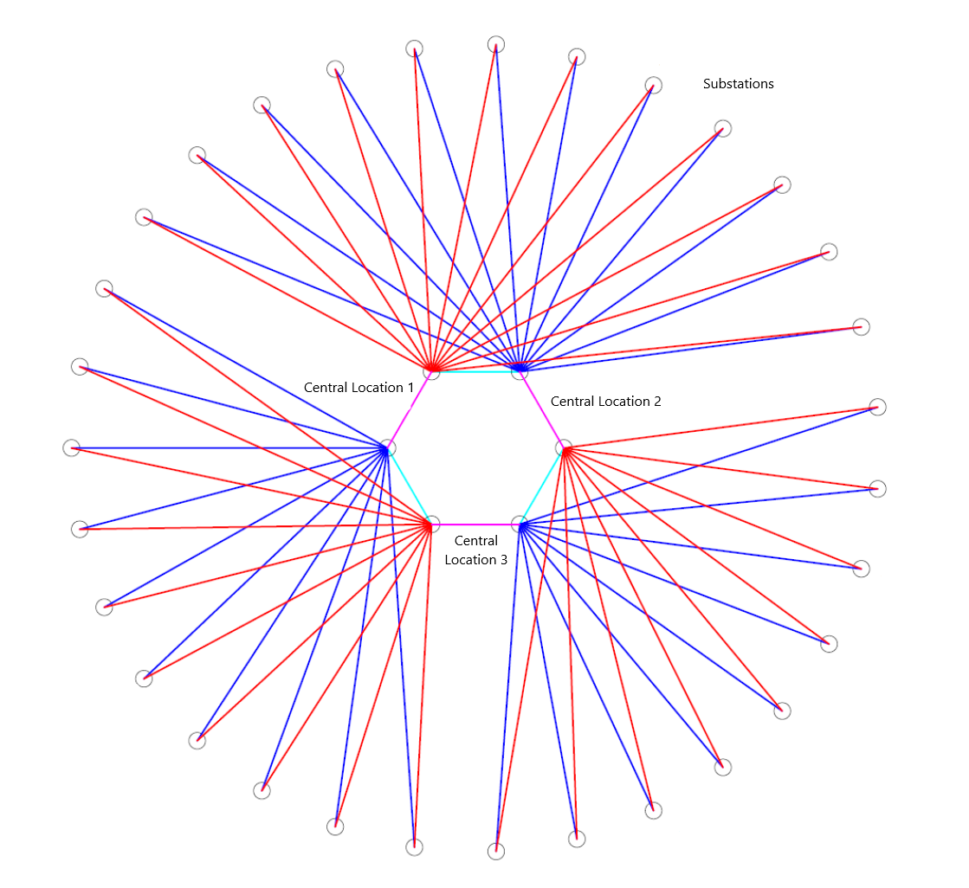
Figure 8: Scheme of the WDM infrastructure

Lifetime cycle
As the electronics have a different life time, the electronic parts are expected to be replaced at midlife time compared to classical sensors. The manufacturer should design its LPIT accordingly, with a proper replacement procedure.

Standardisation
The IEC decided to restructure the old IEC 60044 series and transform it into a new set of standards, IEC 61869, composed of the following general requirements and specific documents.
The main standard that regulates them is the IEC 61869 series, in which the IEC 61869-1 [1,2] describes the general requirements applicable for all ITs.
Parts -2 to -5 documents of the series deal with specific requirements for each type of conventional transformer (current and voltage ITs in IEC 61869-2 and -3, respectively [173￼4]).
For LPITs, part -6 adds general requirements applicable for all types of LPITs. [2]
Parts -7 to -15 documents of the series deal with specific requirements of each type of LPIT (voltage, current and combined ITs with electronic in IEC 61869-7, -8 and -12, respectively [8,9]; passive current and voltage LPITs in IEC 61869-10 and -11, respectively [6,7]; DC current and voltage LPITs in IEC 61869-14 and -15, respectively ). Part -9 describes the digital interface for LPITs [5]. The table below shows the different parts of this standard:

PRODUCT FAMILY STANDARDS  IEC |  | PRODUCT  STANDARD  IEC | PRODUCTS
61869-1  GENERAL  REQUIREMENTS  FOR  INSTRUMENT  TRANSFORMERS |  | 61869-2 | ADDITIONAL REQUIREMENTS FOR CURRENT TRANSFORMERS
 |  | 61869-3 | ADDITIONAL REQUIREMENTS FOR  INDUCTIVE VOLTAGE TRANSFORMERS
 |  | 61869-4 | ADDITIONAL REQUIREMENTS FOR COMBINED TRANSFORMERS
 |  | 61869-5 | ADDITIONAL REQUIREMENTS FOR  CAPACITOR VOLTAGE TRANSFORMERS
 | 61869-6  ADDITIONAL  GENERAL  REQUIREMENTS  FOR LOW-POWER  INSTRUMENT  TRANSFORMERS | 61869-7 | ADDITIONAL REQUIREMENTS FOR  ELECTRONIC VOLTAGE TRANSFORMERS
 |  | 61869-8 | ADDITIONAL REQUIREMENTS FOR  ELECTRONIC CURRENT TRANSFORMERS
 |  | 61869-9 | DIGITAL INTERFACE FOR INSTRUMENT TRANSFORMERS
 |  | 61869-10 | ADDITIONAL REQUIREMENTS FOR  LOW-POWER PASSIVE CURRENT TRANSFORMERS
 |  | 61869-11 | ADDITIONAL REQUIREMENTS FOR LOW-POWER PASSIVE VOLTAGE TRANSFORMERS
 |  | 61869-12 | ADDITIONAL REQUIREMENTS FOR  COMBINED ELECTRONIC INSTRUMENT TRANSFORMERS AND COMBINED  STAND-ALONE SENSORS
 |  | 61869-13 | STAND-ALONE MERGING UNIT
 |  | 61869-14 | ADDITIONAL REQUIREMENTS FOR  CURRENT TRANSFORMERS FOR DC APPLICATIONS
 |  | 61869-15 | ADDITIONAL REQUIREMENTS FOR  VOLTAGE TRANSFORMERS FOR DC APPLICATIONS
Source IEC.
At the time this document was written, some parts marked in brown are still under development, and the IEC will aim to issue the remaining parts soon. For these, the corresponding parts of the former IEC 60044 are applicable. In fact, the EITs still rely on the old Standard series 60044-7 and -8 [8,9],.

LPITs and metering for billing
At the time of writing this chapter, users regretted that LPITs could not be used for metering for billing, the simple reason being the legal aspect. Behind this summary lies a forgotten principle of today's installations: legal metrology.
Today's metering systems are designed to operate fairly and impartially. First and foremost, it shall measure quantities of voltage, current and energy within the tolerances defined in the relevant product standards. Metrological performances can be verified using methods and, above all, metrological tools, which are periodically checked and linked to the fundamental quantities of voltage and current. This allows, in the event of a dispute between users, to carry out a contradictory measurement of the installation by accredited agents equipped with tools linked to the fundamental quantities.
When it comes to employing digital technology, new methods and tools have to be rebuilt. Metrology and international organisations have taken up this challenge.
This has led to developing the metrological infrastructure needed to offer calibration services for non‑conventional current and voltage sensors (see EMRP projects FUTURE GRID I and II [20]).
On the standardisation front, IEC TC38 has launched a revision of the IEC 61869 part 7 and 8 standards for LPITs with electronics and digital output 61869-9, as part of the TC38-WG37 working group.
It should also be noted that IEC TC13, which is responsible for revenue metering, has launched a working group to publish IEC TS 62053-25 ED1 Electricity digital revenue metering in 2024 (source IEC.ch).
Finally, CIGRE has also launched a working group TOR-WG B5.76 ‘Architecture, Standards and Specification for metering system in a Digital Substation and Protection, Automation and Control environment’ that will explore the typical use cases and give guidance.
These publications will be fundamental references for the legislator, who will design a legal framework for digital input metering.

References
- IEC 61869-1:2011. Instrument Transformers—Part 1: General Requirements; International Standardization Organization: Geneva, Switzerland, 2011.
- IEC 61869-6:2016. Instrument Transformers—Part 6: Additional General Requirements for Low-Power Instrument Transformers; International Standardization Organization: Geneva, Switzerland, 2016.
- IEC 61869-2:2011. Instrument Transformers—Part 2: Additional Requirements for Current Transformers; International Standardization Organization: Geneva, Switzerland, 2011.
- IEC 61869-3:2011. Instrument Transformers—Part 3: Additional Requirements for Inductive Voltage Transformers; International Standardization Organization: Geneva, Switzerland, 2011.
- IEC 61869-9:2016. Instrument Transformers—Part 9: Digital interface for instrument transformers; International Standardization Organization: Geneva, Switzerland, 2016.
- IEC 61869-10:2018. Instrument Transformers—Part 10: Additional Requirements for Low-Power Passive Current Transformers; International Standardization Organization: Geneva, Switzerland, 2018.
- IEC 61869-11:2018. Instrument Transformers—Part 11: Additional Requirements for Low-Power Passive Voltage Transformers; International Standardization Organization: Geneva, Switzerland, 2018.
- IEC 60044-7:2000. Instrument Transformers—Part 7: Electronic Voltage Transformers; International Standardization Organization: Geneva, Switzerland, 2000.
- IEC 60044-8:2000. Instrument Transformers—Part 8: Electronic Current Transformers; International Standardization Organization: Geneva, Switzerland, 2000.
- V. Skendzic and B. Hughes, ‘Using Rogowski coils inside protective relays,’ 2013 66th Annual Conference for Protective Relay Engineers, 2013, IEEE.
- H. Heine, P. Guenther and F. Becker, ‘New non-conventional instrument transformer (NCIT) - a future technology in gas insulated switchgear,’ 2016 IEEE/PES Transmission and Distribution Conference and Exposition (T&D), 2016.
- T. Buhagiar, J. Cayuela, A. Procopiou and S. Richards, ‘Poste intelligent – The next generation smart substation for the French power grid,’ 13th International Conference on Development in Power System Protection 2016 (DPSP).
- Kayleigh Hutchins, ‘FITNESS project sets roadmap for digital substations’, Electrical Review 2019.
- WG B3.39, CIGRE technical brochure 814, ‘LPIT applications in HV Gas Insulated Switchgear’, 2020.
- SCA3, CIGRE technical brochure 394, ‘State of the Art of Instrument Transformers’, 2009.
- T. Mitsui, K Hosoe, H Usami and Miyamoto, ‘Development of Fibre Optic Voltage sensors and magnetic field sensors’ in IEEE Transaction on Power Delivery, vol 2 jan 1987.
- Kiyoshi KUROSAWA, ‘Development of Fibre-Optic Current Sensing Technique and Its Applications in Electric Power Systems’ PHOTONIC SENSORS / Vol. 4, No. 1, 2014: 12–20
- PAC World Magazine. (2018). Digital Substation. September issue.
- CIGRE B5 Sessions 2020 & 2021: PS 2 / Communications networks in protection, automation and control systems (PACS): Experience and Challenges.
- M. Agustoni, A. Mortara. A Calibration Setup for IEC 61850-9-2 Devices. Euramet FUTURE GRID project. Published in: IEEE Transactions on Instrumentation and Measurement ( Volum.e: 66, Issue: 6, June 2017).
- I.TANNEMAAT, E. SCHENKEL, G. RIETVELD, A. GALLASTEGI, M. ACHTERKAMP. System Accuracy Evaluation of Metering Application based on Optical Current Transformers and IEC 61850 SV Static Energy Meters. CIGRE 2022.
- Ingvill Urdal Rian, ‘Application of Optical Current Transformers in Digital Substations’, MSc Thesis, Norwegian University of Science and Technology, 2018.
- X. MICHAUT, N. SOUPASEUM, V. LEITLOFF, Design constraints and choices for the LAN in RTE's R#SPACE system. CIGRE B5-216_2020.
- R.Koenderman, C. Brauner, Data driven Testing of Digital Substation. PAC World Issue 062 December 2022.
- RTE aims to deploy digital control in its 3,000 substations. The ‘Network Together’ approach [https://www.rte-france.com/fournisseurs/network-together]
- R#SPACE (RTE Smart Protection Automation and Control Ecosystem) – La première brique du cadre d’interopérabilité. [link to RTE website]
- 0 Huet, 0 Maugeard, 0 Chilard, L Popiel, F. Klein, C Moreau, P tantin, J. Pemot, D. Chatrefou, IMPROVING SITE TESTS EFFICIENCY BY REAL-TIME TESTING OF A NEW COMMUNICATION LINK BETWEEN SENSORS AND A PROTECTION DEVICE. 2001 Seventh International Conference on Developments in Power System Protection (IEE). DOI: 10.1049/cp:20010139
- D. Chatrefou, J.P. Dupraz, G.F. Montillet, Interoperability Between Non Conventional Instrument Transformers (NCIT) And Intelligent Electronic Devices (IDE). Published 21 May 2006 Physics 2005/2006 IEEE/PES Transmission and Distribution Conference and Exhibition.
- V. Leitloff, H. Chen, D. Chen, A.Bonetti, L. Xu, A. Mohamed, C. Byman, on behalf of IEC TC95 WG2. - Towards a standardisation for digital inputs and outputs of protection functions in IEC 60255 series. Protection and Control of Modern Power Systems (2022)
https://doi.org/10.1186/s41601-022-00246-x

Applications in Digital HV substations

LPITs in the fully digital substation
Fully Digital substations imply a solution and architecture in which the substation’s functionality is predominantly now achieved in the software. A digital substation is one in which the data related to the primary process are digitised immediately, at the point where the data are measured.
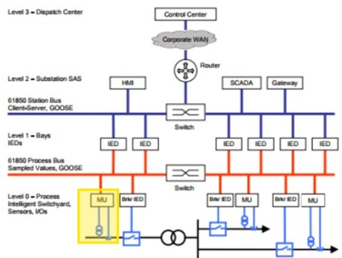
Figure 9 : 61850 substation model
LPITs are obviously part of the Digital Substation (See LPIT in yellow in Figure 9). LPITs are located in the Process Intelligent Switchyard level (level 0) of the IEC 61850 substation model.
For utilities who want to balance the energy trilemma of security, cost and reliability, for efficient and effective investment in power networks, LPITs appear to be a suitable solution for new and modernised substations. LPITs could also help address the need for lower cost and more flexible solutions for substation design, enabling the optimum use of existing assets while reducing system outage requirements for maintenance and construction.[12,13]

The basic steps of introducing digital technology
From a TSO perspective, introducing digital technology is a major challenge. It leads to not to applying the actual PACs but to developing a new FD-PACS design using 61850, which requires new skills to design more efficient project delivery and installation by reducing field cabling, not only by reducing the use of expensive copper but also by minimising engineering efforts, installation and on-site testing.
It starts by testing the design and interoperability in the laboratory [21, 24] especially with the aim of purchasing a multi-vendor FD-PACS.
Then comes the realisation of pilot projects at various scales, starting from a single feeder with LPIT in parallel with a conventional IT to a full digital pilot substation [12, 13].
Theses pilot projects are launched to test new standards for substation designs using new measurement, monitoring, protection and control technologies, with multi-vendor interoperability for digital communications. Three examples of European demonstrators are referenced below:
- The French project named ‘Poste Intelligent’ within RTE (Smart Substation, in English). [12];
- The ČEPS,a.s. pilot project (see §4.1).
These pilot projects make it possible to test:
- new methods and constraints related to the installation of these new technologies in the substations; and
- technology and its performance in real situations.

The pilot project in ČEPS,a.s.
In ČEPS,a.s. a pilot project involving the installation of an optical current transformer (CT) and measurement of current and voltage by sampled values according to IEC61850-9-2 has been in operation since 2017. Sampled values are used for protection and measurement purposes.
The original intention was to compare the behavior of two optical CTs of two different producers with the different principles of current measurement and to evaluate the usability in the conditions of the transmission system. They would have been used in combination with inductive current and voltage transformers, and their outputs should have been compared. Two suppliers were chosen, but prior to the order, one of them discontinued the production of optical CTs. Finally, two optical sensors from the same manufacturer were used.
New current and voltage measurement technology should have been used while maintaining basic rules for protection systems such as two independent protection relays from different producers. This is why two optical sensors with two MUs, which transforms information from transformers to sampled values; two switches for two process buses; and two different protection relays were used. The block scheme can be seen in the following figure:
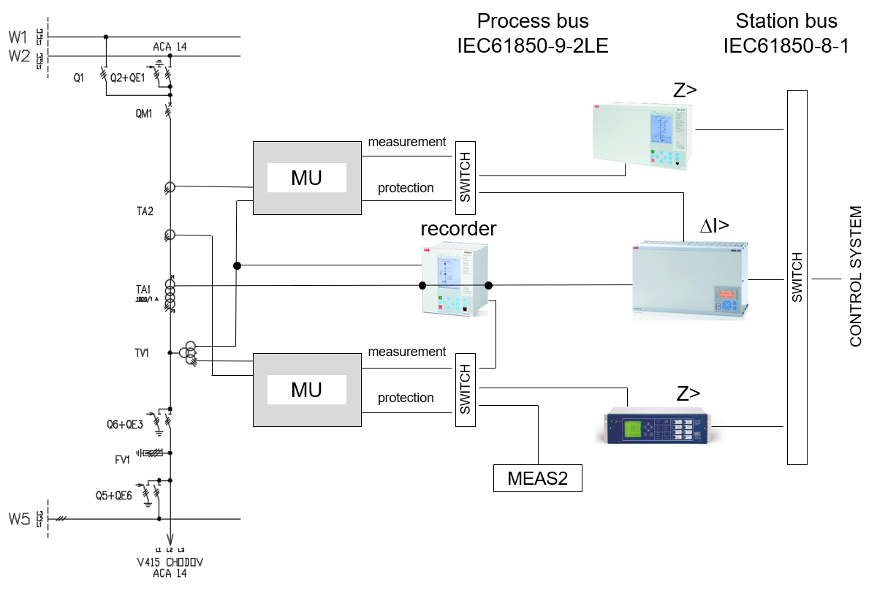
Figure 10: The block scheme of the pilot project
There is a differential relay switched between an inductive CT with analog output and optical CT with sampled values output. In the event of a difference between these two outputs, information is sent to the control system (CS). Furthermore, there is one electrometer which uses sampled values installed there. The measured value is compared with a classical electrometer. To easily compare voltage and current outputs, the fault recorder is also installed there. It records the analog outputs of both voltage and current transformers and a digital output of the optical sensor and the output of the voltage transformer changed into digital values.
The main purpose of the pilot project was to verify the new optical CT technology and the possibility of its use for measurement and protection. The simplest scheme was chosen, which only replaces the existing state with new devices. At first sight, it is obvious that the reliability of the entire system is reduced here. Among the secondary technology devices and the optical CT, new electronic equipment has been added that can break down. Furthermore, all devices must be time-synchronised with high precision to hundreds of nanoseconds. The entire system thus becomes dependent on reliable time synchronisation. In this project, the exact time is obtained from a GPS receiver and Meinberg M500 time server.
For real use, it would be necessary to choose another, more reliable scheme.
Evaluation of the protection system
The functionality of time synchronisation is essential for the proper function of protections. The following figure shows the impact of the loss of time synchronisation on the equipment. operation. 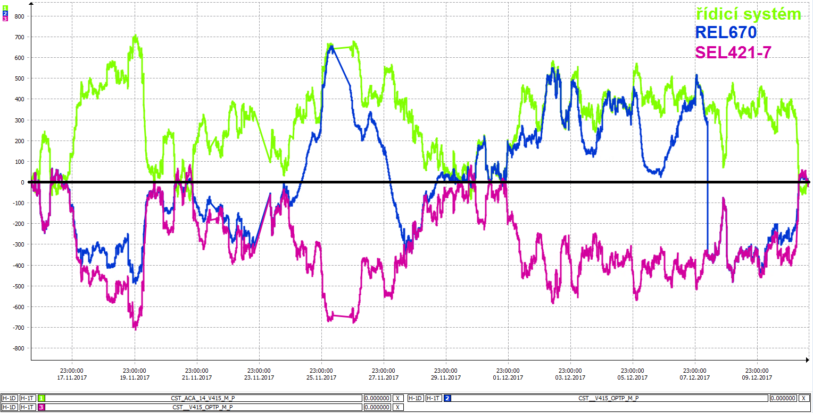
Control System
Figure 11: Measurement of active power when time synchronisation is lost (11/17/2017-12/11/2017)
Using the example of the measured active power from REL670, we can see that it differs from SEL421-7 and does not correspond to the opposite values from the CS (measured values from the CS are obtained from inductive current and voltage transformers). Compared to protections, the CS has the opposite power sign convention, so the measurement is correctly axisymmetric along the x-axis in this case. In the case of the REL670, it was occasionally synchronised and measured correctly before losing synchronisation again. SEL421-7 used to be synchronised differently via the IRIG-B protocol.
The values of measured currents in the same period for all mentioned devices (REL670, SEL421-7 and conventional CS) are practically identical, as shown in the following figure.
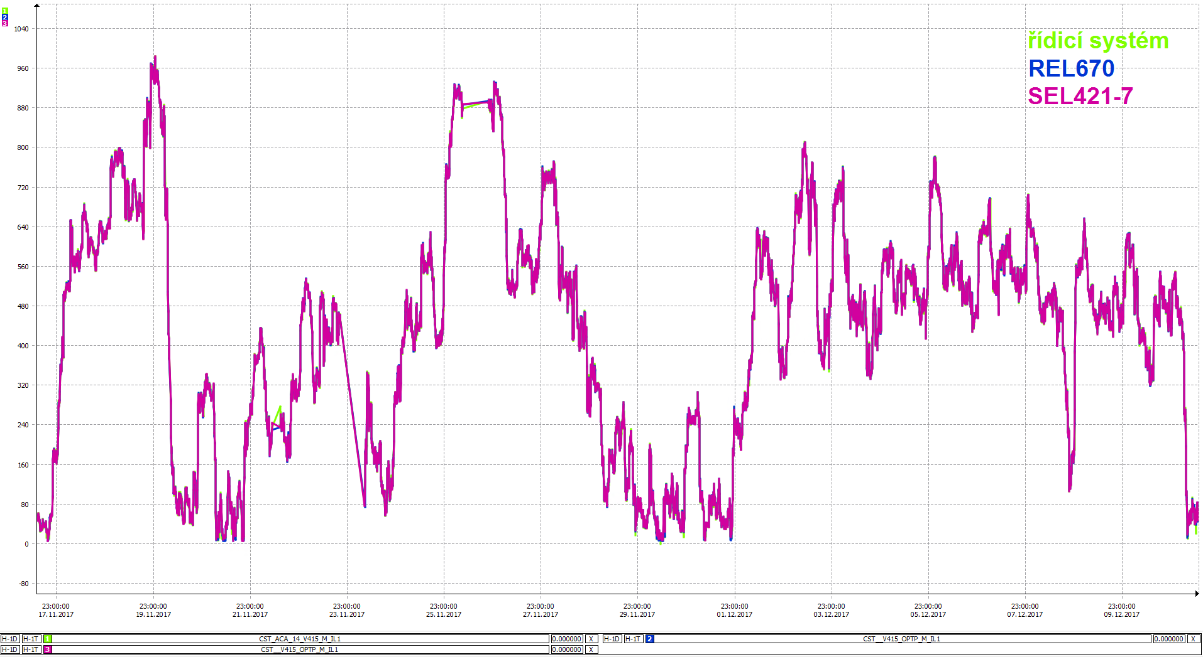
Control System
Figure 12: Current measurement in the same period (17.11.2017–11.12.2017)
Incorrect values of the measured power are caused by the incorrect time synchronisation of current and voltage samples when calculating the power. In a similar manner, a similar error occurs when calculating the impedance from the current and voltage, which in the case of distance protection relays threatens the proper functioning of the protection.
There was only one fault on the protected line since commissioning. The fault occurred in the second phase approximately 120 km far from the substation. The difference in the measured values between the optical CT and the inductive CT was within 1.5% most of the time, and the total impedance error was within 3%. The protection thus responded to the fault according to the set characteristics.
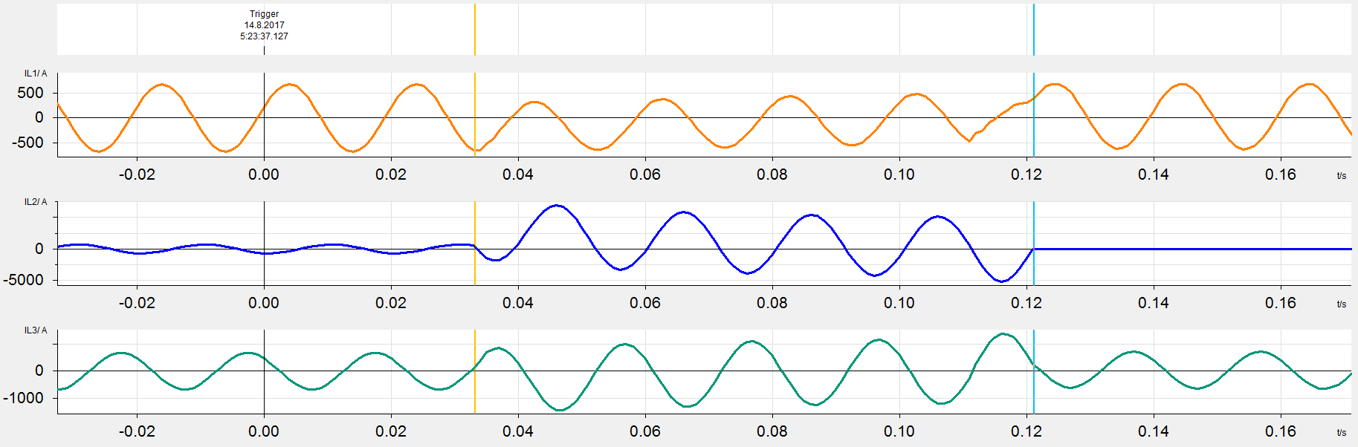
Figure 13: Measurement from the inductive current transformer during a fault in L2
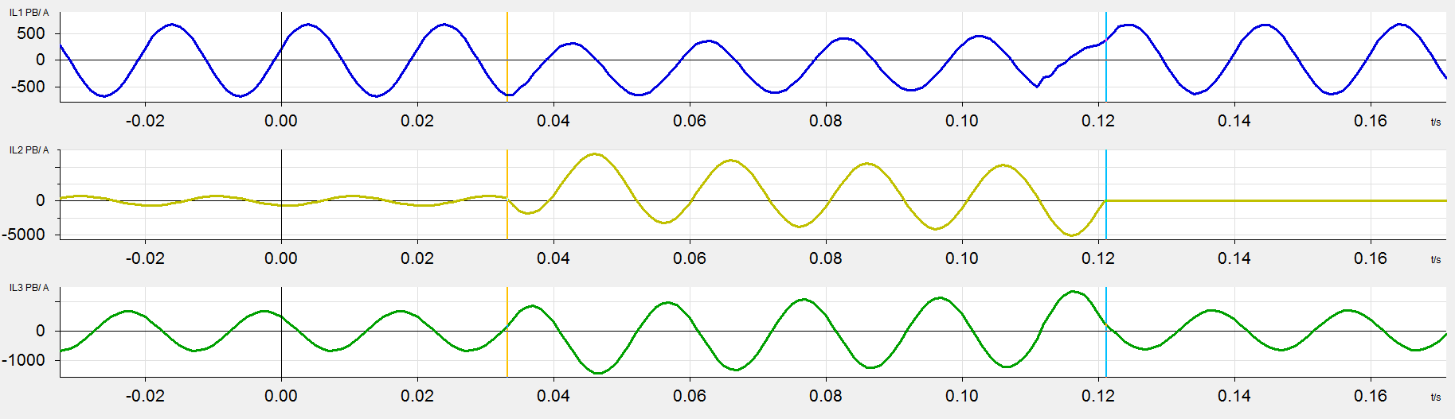
Figure 14: Measurement from the optical current transformer during the fault in L2
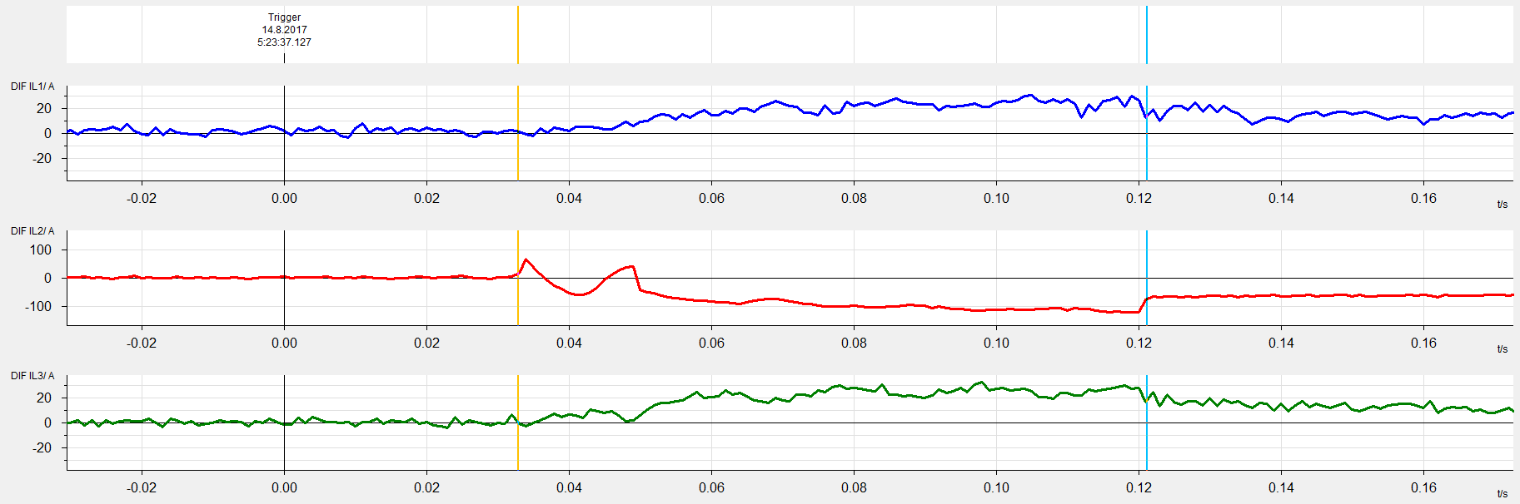
Figure 15: Instantaneous differential current values between the inductive and the optical current transformer
The record of the instantaneous differences in measured currents between the inductive and the optical CT is obtained from the fault recorder. In the phase with fault (L2), a maximum instantaneous current difference of around 110 A appears.
Within the pilot project, time synchronisation was the most problematic from the protection point of view. Because the exact time must be available non-stop 24 hours a day for proper operation, it is necessary to pay significant attention to the implementation of time synchronisation and ensure its high reliability. In the pilot project, it was necessary to solve problems with time synchronisation at the beginning such as: HW error of the GPS receiver card, firmware compatibility in the devices used, location of the antenna for the GPS receiver, etc.
Devices compatible with IEC 61850-9-2 are required to receive sampled values. Because the current set of standards 61850 works with a sampling rate in the range of low kilohertz, the use of modern devices based on electromagnetic waves – wave protections and wave locators, which work with a sampling rate of 1 MHz – is excluded.
The following advantages and disadvantages of using optical CTs emerged from the experience of the pilot project:
- Advantages:
The measurement is linear and accurate over the entire range. This ensures sufficient accuracy for protection and commercial measurements, even with a single measuring sensor. Compared to inductive CTs, saturation, which has a negative effect on the function of protections, cannot be achieved. Optical CTs do not contain an iron core, so there is no risk of ferroresonance.
- Disadvantages:
Operational experience has shown the absolute dependence of measurement on precise time synchronisation. In the event of time synchronisation loss, protection relays immediately stop fulfilling their function.
In the case of optical CTs, it is necessary to expect a shorter service life, or the need to replace the secondary part during the life cycle. The secondary part of the OPTP is mainly composed of electronic devices, which have roughly half the life of conventional power devices.
Although optical CTs reduce the need for installation space in a bay of the substation, in contrast, they increase the need for space in the switchboards of the secondary circuits. Furthermore, they require an auxiliary power supply for their function.
Outputs from optical CTs are not usable for power quality evaluation and diagnostics as they cannot measure the higher harmonics required by legislation.
The use for commercial measurement is currently questionable due to the lack of any legislation allowing the use of digital data processing.

RTE’s experience
In 1998, the French TSO decided to assess the optical current measurement technology in collaboration with two suppliers, one for LPIT, the other for protection devices [27]. The project has two main objectives:
- To provide technical specifications of new sensors, including both functional features, test requirements and performance requirements concerning the communication protocol.
- To demonstrate the feasibility of the Optical current LPITs and their communication system to the protection through simulator tests and field tests on a 400 kV AIS line feeder.
The available standards were IEC 60044 and the very first 61850-9-1 communication protocol.
In 2004, the good performance of the digital products during the previous pilot project led RTE to launch another pilot for GIS application [28] with the implementation of the improved 61850-9-2LE communication protocol on a 245 kV line feeder. This second pilot project also showed good results, but it was difficult to go further than a single feeder pilot project.
In 2014, with the publication of the second edition of the IEC 61850 standard and the emerging need for Smart-grid solutions, RTE launched ‘Poste Intelligent’: a pilot project to experiment a fully digital AIS substation [12]. The aim was to test in real conditions the latest technological developments for both primary and secondary equipment using the second edition of the IEC 61850 standard and latest information and communication technologies in a fully interoperable solution. For the first time in France, the substation was designed like an autonomous entity, with adaptive solutions using horizontal inter-substation communications, in addition to the traditional hierarchical concept of ‘substation to SCADA’. A FD-PACS system using a redundant 61850-9-2LE process bus gathering LPITs and conventional ITs with a Stand Alone Merging Unit (SAMU) was successfully installed in a refurbished substation and successfully operated.
This project was a major ‘key-change’ for RTE.
In 2019, via its web site, RTE declared its aims of deploying digital control in its 3,000 substations [25]. Manufacturer and digital solution providers were invited to join the ‘Network-Together’ organisation, sharing valuable solutions for the future HV electric grid. The RTE’s next PACS generation will be a FD-PACS using the latest improvements of the IEC 61869-9 digital sampled value telegram format in accordance with the digital improvement of the protection standard IEC 60255 [29]. At the time of writing this chapter, this FD-PACS named ‘R#SPACE’ [23, 26] is still on-going and, when it is deployed, it will allow install and operate LPITs.
Experience learned: At the beginning of the introduction of Digital IEC 61850-9-2 technology, the lack of standardisation and dependency on a single vendor solution was the main obstacle in adopting LPIT technologies. It also led to unfamiliarity with LPIT’s technology in association with IEC 61850 substation solutions. Experimenting in the demonstrator helps to evaluate expectations based on historical background regarding substation design and considering the decision to substitute conventional IT technologies with LPITs.
With the help of the improving standardisation, many choices have to be considered for specifying suitable LPITs such as reliability and dependability, interoperability with the expected functions and many other topics that led to improving the LPIT specification. For example, the LPIT specification was improved with a redundancy requirement that allows multiple sensing elements in the same IT. Moreover, RTE showed interest in HV combine unit LPITs, especially for voltages over 145 kV, for which there is almost no conventional combined unit on the market. Concerning the lifetime topic, a requirement was introduced in the specifications of the LPIT design that led to allowing a replacement of the electronic components at mid-lifetime, at a time when the LPIT will be expected to be in operation in the field. The design of the LPIT shall allow easy repairs and replacements for its electronic parts. It is preferable to promote technology that does not require on-site re-calibration after this replacement.
RTE learned that installing LPITs led to managing some particularities with the link. Depending on the link cable type chosen by the manufacturer, it was sometimes mandatory to keep the length of the cable as sometimes cables are part of the calibration, meaning that the design of the substation could have dedicated areas to storing the ‘over length’; moreover it also raises the topic of managing the availability of the spare cable. Then is preferable to promoting technology that can allow different lengths of the cable link with easy installation and maintenance.
Although it is required to avoid on-site calibration during the life-time of the device, to allow investigation during the preliminary experimental phase, a procedure for checking the calibration using portables tools could be designed by the manufacturer. This could allow on-site investigation without requiring the LPIT to be sent back to the laboratory, a situation that can be very complicated for LPITs in GIS.
At the time of writing the document, the use of meters for billing is awaiting legal agreement (see §2.7), but actual meters are a very useful tool for recording energy measurement and can be part of the experimental phase. For demonstration purposes, the measurement of a metering systems using LPIT can be compared with a metering system using trusted conventional IT [14]. The two independent meters/metering instrument transformers can be compared. In case of deviations, it leads to investigations.
For Diagnostic and Monitoring, valuable information available on the MU shall be transmitted to the PAC system according to the 61850 PAC data model. This raises the question of testing interoperability with the PAC system. RTE solved this issue by creating its own laboratory where communication and behavior of the SAMU or LPIT can be tested in interaction with RTE’s FD-PACS ,named R#SPACE. For on-site diagnostics, new digital tools are required to allow remote local diagnostics to complete the remote diagnostics and remote configuration.

TSOs questionnaire
A questionnaire was developed by the TSOs represented within or contacted by ENTSO-E SG Protection Equipment subgroup to understand the state of the art regarding the use of LPITs on transmission networks.
The questionnaire was divided into three main sections:
- Conventional IT: the goal of this section was to have some feedback about Conventional IT experiences.
- Prerequisite for LPITs: the goal of this section was to set up the possible prerequisites to install an LPIT in a substation.
- Use of LPITs: the goal of this section was to present the first use and feedback on LPIT usage.
- LPIT Strategy: the goal of this section was to present some strategies to install LPITs and the benefits and drawbacks of LPITs.
TABLE 1 shows the 17 members of ENTSO-E SG Protection Equipment that completed the questionnaire.
Country | TSO
Austria | APG
Belgium | Elia
Czech Republic | CEPS
Estonia | Elering
Finland | Fingrind
France | RTE
Germany | 50Hertz
Germany | Amprion
Germany | Transnet
Italy | Terna
Latvia | AST
Netherlands | TenneT
Norway | Statnett
Portugal | REN
Romania | Transelectrica
Serbia | EMS
Spain | REE
TABLE 1 : TSOs’ participants in the questionnaire

Conventional Instrument transformer
Q1.1: Have you experienced any incidents regarding ‘conventional’ instrument transformers (reliability, explosion …)? If yes could you describe them?
The first question of the questionnaire concerned the experience of any incidents regarding conventional ITs. The goal of this question was to analyse the various types of incidents and to establish if these incidents could occur if an LPIT was installed instead.
The first thing to note is that almost all TSOs have experienced some incidents regarding conventional ITs, although many of them insist that the occurrence is low.
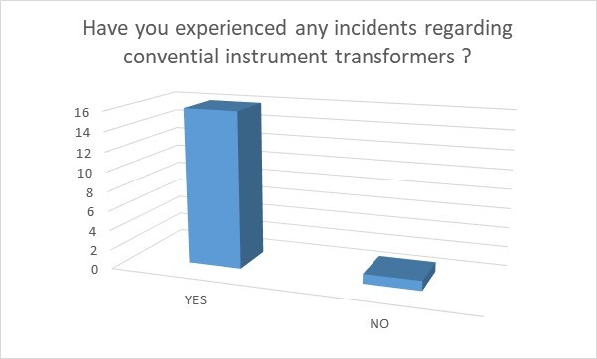
The different types of incidents that were noted are:
- Insulation media leakage;
- Dissolved gases;
- Explosion due to overvoltages on a degrading insulation;
- Explosion due to thermal runaway issues triggered by degraded oil quality (moisture ingress);
- Humidity penetrated inside the CVT and caused an explosion; and
- Internal fault which leads to fire.

Q1.2: Do you have any maintenance policy regarding ‘conventional’ instrument transformer? If yes, could you describe it?
The goal of this question was to compare the various maintenance policies regarding conventional ITs.
The first thing to note is that all TSOs have a maintenance policy; however, only a few TSOs have a maintenance policy based on the age (i.e. the failure rate) to build an optimised policy. Other TSOs have a different frequency period regarding the manufacturer’s requirement and the corporate strategy (which can be regularly reviewed).
The various maintenance checks are:
- Visual check (visual condition of the equipment, oil leak, oil level, SF6 pressure, etc.) : this check is performed from once a month to once a year depending on the TSO;
- Cleaning (insulator);
- Inspection (including diagnostic); and
- Thermo-photo.

Q1.3: What are the criteria to replace a ‘conventional’ instrument transformer? If it is a fixed duration, which duration?
The goal of this question was to list the various criteria for replacing a ‘conventional’ IT and see, if nothing happens, if the change is defined by time or by other methods.
The criteria to replace a ‘conventional’ IT can be:
- A change on the substation technology (AIS to GIS for instance);
- Oil or gas leakage detection;
- Renovation of a substation; or
- Damage

The date replacement of a conventional IT, if nothing happens, is either a fixed time (from 15 years to 40 years) or a time dependent on various criteria (inspection, health index, substation change, …)

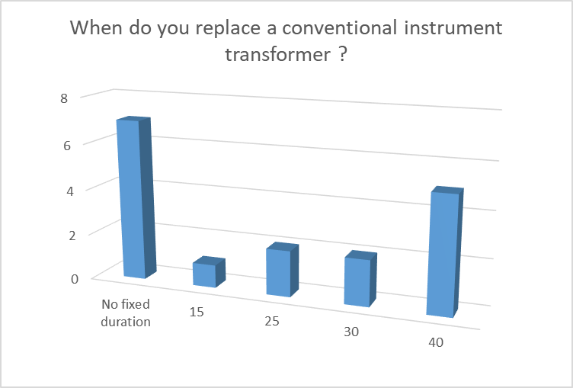

Q1.4: Do you have Capacitive Voltage Transformers in your network? If yes, what percentage are connected to equipment able to measure harmonics (for instance P,Q Sensor) ?
As the capacitive voltage transformer (CVT) does not deliver an exact image of the primary voltage (regarding harmonics), the goal of this question is to see if the CVT is mainly used on the electric network and if the harmonic’s measurement is widely performed.
Almost all TSOs have CVTs in their network. It can, however, be noted that one of the TSOs has a program to replace them by inductive voltage transformer due to the failure statistics and health index. Another one pointed to the risk of ferro resonance with an inductive voltage transformer, which forced them in some conditions to use a CVT.
Harmonics’ measurement does not seem to be a significant concern as most of the TSOs did not answer this question or else answered that they do no measure harmonics (or do so just in a few specific localisations). When they do, it can be either by a PQ Sensor or by using an inductive voltage transformer.
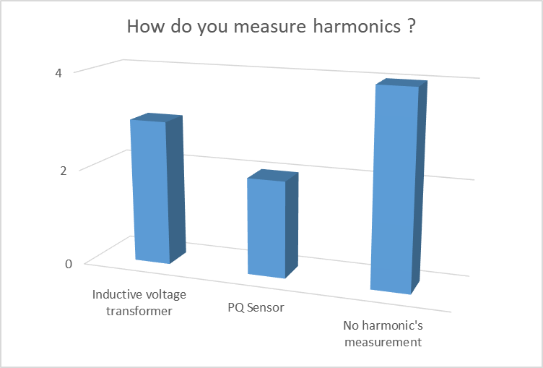

Q1.5: What are the criteria to install equipment which is able to measure harmonics?
The goal of this question was to see in which situations a harmonic measurement is needed. Depending on the TSO, the following situations were cited:
- Feeders connected to large power customers (for instance industrial customers);
- Feeders connected to power electronics (windmill or photovoltaic installations, HVDC, etc.);
- Feeders connected to generation installation;
- Feeders connected to international grid interconnections; and
- Feeders connected to potential harmonic polluter.

Prerequisite for LPITs
Q3.1: Is a process bus a prerequisite for using LPITs for your applications?
Eleven TSOs answered this question; 6 of them consider that a process bus is a prerequisite for using LPITs. However, some applications using LPITs may not require the use of a process bus. The two most named applications are monitoring equipment using merging units and fault localisation. For protection IEDs, the use of a process bus is a prerequisite.
Moreover, LPITs which are built in compliance with IEC 61869 standard must have an analogue output. It is therefore possible, with this technology, to use LPITs without a process bus.
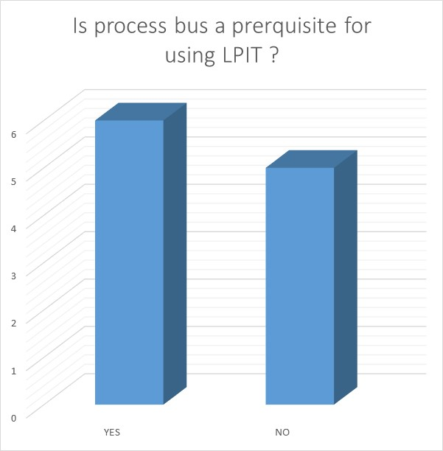

Q3.2: According to you, is it useful or advisable to use an LPIT and conventional IT (with SAMU) in the same substation?
Nine TSOs answered the question, and the answers contrast greatly. On the one hand, some TSOs think that this situation is inevitable given the long life cycle of conventional ITs. It is therefore the only way to start to install LPITs in a cost effective manner. On the other hand, other TSOs think that it is not advisable to mix different technologies (with for instance a different transient response or different saturation level) within one substation.
In one TSO’s pilot, only current LPITs have been tested. Therefore, both conventional voltage transformers and optical CTs are mixed on the same substation.
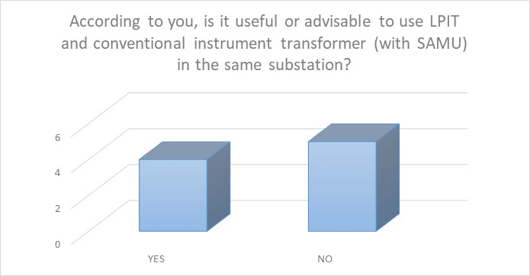

Q3.3: Do you plan to use or are using IEDs that publish SVs for other users (protective or not)?

The goal of this question was to see the possible use of SVs to communicate from one IED to another user (protective or not). Thirteen TSOs answered this question, and it appears that this use of SVs can be very interesting and shows good potential for the future.
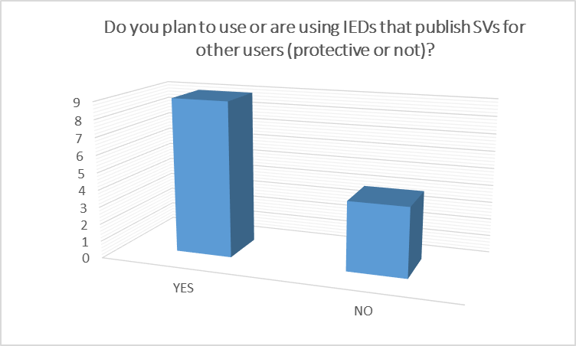

Q3.4 How do you solve the compatibility of transient responses of classical CTs and non-conventional CTs (one installed on one side of a link, the other one installed on the other side).

The goal of this question was to see if a mix of LPITs and classical ITs could be installed and connected to the same line or busbar differential protection. Five TSOs answered this question and there are various strategies to deal with this problem:
- The first is to impose the same technology at both sides of the line (for a line differential protection) or the busbar (for a busbar differential protection).
- The second is to make corrections in the system (emulate the saturation behaviour, adjust the relay with a certain bandwith,…) to prevent a saturation of the CT on one side and not on the other side of the line.
- The third is to trust the supplier to furnish a system which is operational.

Two pilots who combine measurement from a classical CT and from a LPIT have been already made, and it seems to work well under operational conditional and during an external fault (no fault on the protected zone yet).

Q3.5: According to you, what are the protection IED prerequisites for being connected to an LPIT?
The goal of this question was to see the prerequisites regarding protection IEDs for being connected to LPITs (as a main use of LPITs is to be connected to a protection IED). Eight TSOs answered this question and the different prerequisites presented are:
- Allowing the interoperability and interchangeability (for instance by using a standardised communication protocol or a standardised analogue signal format;
- Support the use of a process bus to connect to the LPIT;
- Should be able to compensate for the difference in sensor characteristics; and
- Able to use sampled value (or using the analogue output of the LPIT).

Use of LPITs

Q4.1: Which type of LPIT technology have you experimented with?
The goal of this question was to have an initial overview of the different types of LPIT which have been tested during pilot experimentation.
First, it can be seen that 7 of the 17 TSOs who answered the questionnaire already have a pilot substation with LPITs. The two types of technologies that have been tested are:
- Optical CTs based on a Farraday effect;
- Combined CT and VT using Rogowski coil.
Moreover, pilots have been performed both on GIS and AIS.
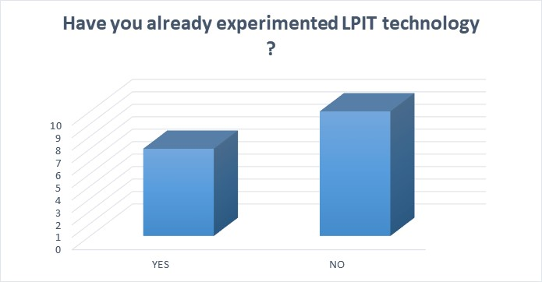

Q4.2 Which standard and accuracy class have you used?
The goal of this question was to see which standard the TSOs have used to trial LPIT technology. The two main standards which have been mentioned are IEC 61869 and IEC 60044 (mainly 60044-7 and 60044-8).
Only a few TSOs answered the question about the accuracy classes which they have used. The answers were 0.2 S and 0.5S (for the measurement CT) and 5P or 5TPE (for the protective CT).

Q4.3 Have you already commissioned an LPIT connected to a functional protection chain ?
The goal of this question was to see whether the commissioned LPITs were connected to a functional protection chain. Six of the 7 TSOs who have performed pilots answered this question. Only one has tested a commissioned LPIT with trip contacts connected. When LPITs were tested in an operational substation, it was usually in parallel with a conventional system. Another test application is to detect faults in a cable and therefore block the auto-reclosure of the circuit breaker. In this case, the LPIT was installed in a transmission tower.

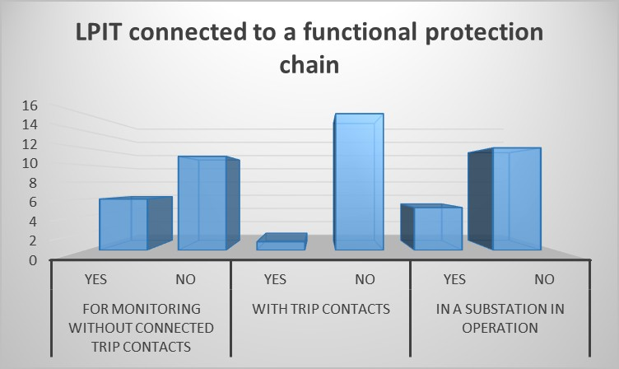

Q4.4 Have you identified the need to use LPITs in conjunction with traveling wave-based applications?
The traveling waves need at least a minimum sampling rate of 1.25 Mhz to function properly. However SMV can only give 12 kHz ,so it is not usable for this purpose. The goal of this question was therefore to see if it is a drawback for the use of LPIT or if there is no need to have an LPIT application and a traveling wave application at the same time.
The answers to the questionnaire show that most of the TSOs who answered either do not need to have both applications at the same time (7 TSOs) or do not use traveling waves (3 TSOs). However, 3 TSOs would like to have LPITs and use traveling waves, so it should be a subject of interest in the future.

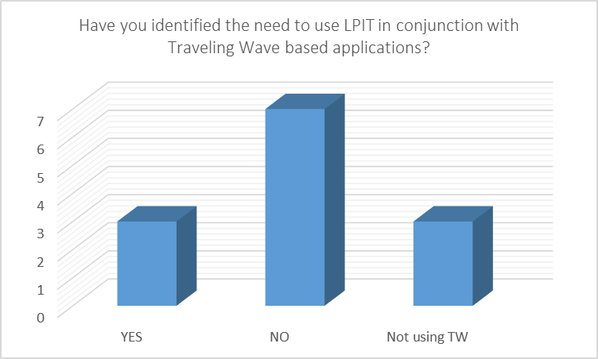

Q4.5 On what voltage level do you intend to use LPIT?
The goal of this question was to see if there are some voltage levels where LPITs are more appropriate for installation than others. It appears that the voltage level is not a criteria to install LPITs. Only one TSO reported that the ratio of cost/benefits for medium and low voltage LPITs is insufficient to install LPITs at these voltages.

Q4.6 Have you already performed some validation tests for LPITs? Which ones?
The goal of this question was to analyse which type of tests have already been performed. There are three main types of tests:
- Standard factory and site acceptance tests (according to the standards 60044-7 and 60044-8)’
- Comparing the measuring values of LPIT with parallel installed conventional ITs in a pilot project’ and
- Interoperability test in a laboratory.

Q4.7 Could you share some feedback about:

As only a few TSOs have built some pilots, for each answer only two or three TSOs have provided an answer. Therefore, the following feedback is not exhaustive and represents only some key points for each subject.

Engineering | The questionnaire answer focused on various points of attention:  - Reliability: the reliability of the whole system can be reduced because new elements such as MUs or switches are introduced.  - Splicing of fibre: There are different types of connector for optic fibre. Therefore, particular attention must be paid to choose the right one.  - Time synchronisation: all IEDs shall work with sampled values based on the same time.
Installation (including connectors) | Globally the answers inform that the installation is much easier, safer and less time-consuming than the conventional one.  However, engineering and putting into operation (especially the first time) is more complicated.  One TSO encountered an issue with the secondary fibre lengths, which are set in the factory and can’t be adjusted on site.
Site Test | The feedback of the site test was good as most of the tests were done during factory acceptance tests. On site proper measurements such as ratio check and the phase sequence were performed.  One TSO noted that specific IEC 61850 tools are needed to perform some tests.
Calibration | It has been noted that sometimes LPIT calibration (certification from a legal metrology point of view) causes an issue for revenue metering application. This case is not yet covered by the national law.  When a calibration must be performed, specific IEC 61850 tools are needed, and some technologies require fairly heavy tools to perform it.
Repair or exchange | The two TSOs’ strategies provided in the answer mentioned :  - An exchange more than a repair;  - The electronic part must be changed at half the lifetime of the LPIT.  Some questions still require answering to define a good maintenance strategy :  - Will usable electronic components be available in 20 years for possible repair?  - Will the parameters of interconnecting optical fibres change over time, or how?  - The sensors in each phase are factory-calibrated with their MU and optical cable. It must not be swapped on the construction site. Will this be possible when replacing part of the device?
Connection with measurement device | Two TSOs have tested this connection and the test was passed as the MU has an independent output with a higher sampling rate than for protection purposes. There is no difference in connection. Both are connected to the same process bus.
Connection with distance protection | Different pilots have been performed and everything went smoothly. Up to today, no fault occured on the line, so the distance protection has not been tested when a short circuit occurs on the line. However, it has worked well during operational conditions.  One TSO also combined measurements from a conventional voltage transformer and from an optical CT for distance relays of two manufacturers. Secondary analog voltage is transformed into sampled values.
Connection with line differential protection | No test yet
Connection with busbar differential protection | Only one TSO has a pilot with a busbar differential protection: in this pilot, both measurements from a conventional CT and from an optical current transformer were combined for a busbar differential protection. One bay unit measures the analog value, and the second measures sampled values from the optical current transformer. It appears to work well under operational conditions and during external faults.
Connection with transformer differential protection | Only one TSO tried to connect an LPIT with a transformer differential protection and there were synchronisation problems between the primary and the secondary side, and therefore the transformer differential protection didn’t work.
Time synchronisation | The previous item shows that time synchronisation appears to be the weakest point.  At the time of installation of different pilots, not all manufacturers had implemented PTP synchronisation. Some devices are synchronised differently. Therefore, it can take a long time to align devices synchronised differently from different manufacturers.

LPIT Strategy
Q5.1 When you install LPITs, will you install them for the whole substation, for the whole voltage level or can it be just for a bay (the other bays could therefore be with conventional ITs) ?

There were two ways of answering the question:
- For a pilot project: the TSOs who answered this question regarding the strategy for a pilot project answered that it is usually only for one bay (or some bays in the substation but not all of them) with or without trip contact (see question 4.3)
- For the strategy in operation: the answers are very different. Some will install them only for the whole substation, whereas others will install them individually. Others will also have a different strategy whether the substation is new (all LPITs) or existing (only replacing by LPITs the ITs which need to be replaced and only if there is a process bus).

Q5.2 What is the strategy to connect LPITs with busbar differential protection?
Only 4 of 17 TSOs already have a strategy to connect LPITs with busbar differential protection. For the other, either the strategy is not defined yet or there is no interest in using LPITs with busbar differential protection.

For those who have a strategy, there are different methods:
- Using process bus and PTP, most probably as decentralised BBP, with central unit and respective bay units.
- Combined measurements from a conventional CT and from an optical CT for a busbar differential protection. One bay unit measures the analogue value and the second one measures sampled values from the optical CT.
- Use a busbar differential protection which allows the use of LPITs and installing it only when all the bays are connected to a process bus (either with LPIT or with a conventional instrument transformer with SAMU).
- Install LPITs in the whole substation.

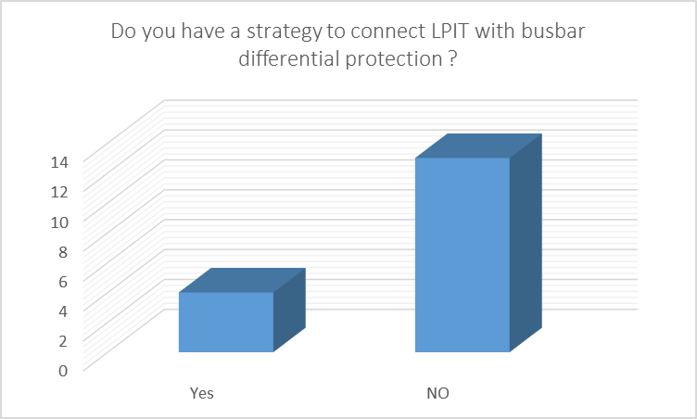
Q5.3 Have you planned to install LPITs in the future? How many ?

The goal of this question was to have a first overview of the number of TSOs who already have a strategy to install LPITs. The answers to this question are divided into three groups:
- The first group, who answered ‘No’, includes TSOs that either do not have the willingness to install LPITs yet or are waiting to see the result of a qualification to establish a strategy.
- The second group, who answered ‘Only in pilot’, includes TSOs that are willing to perform a pilot project to evaluate the results before establishing a strategy.
- The third group, who answered ‘yes’, includes TSOs who have planned to use LPITs in the future. There are different types of strategies which are reported:
  - Planning to install more than 100 LPITs within 10 years;
  - Planning to install LPITs only when it is needed for a specific application (for measurements of the harmonics in GIS);
  - Willingness to install some LPITs but without a defined number.

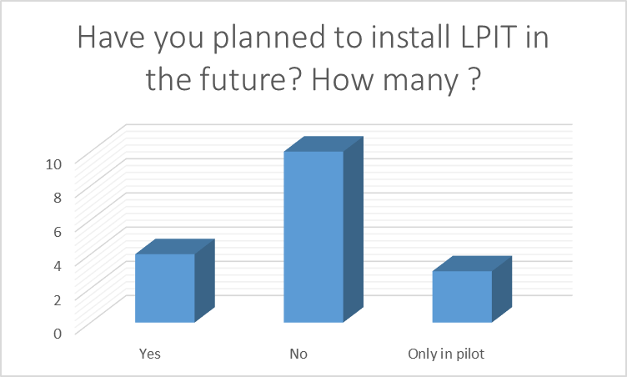

Q5.4 Have you already written a specification about LPIT?

The goal of this question was to know how many TSO have already written some specification for LPITs. The results show that most of the TSOs do not have a written specification yet, which confirms that the LPIT topic is just starting: only 4 TSOs have already written a specification and another one is working on it.

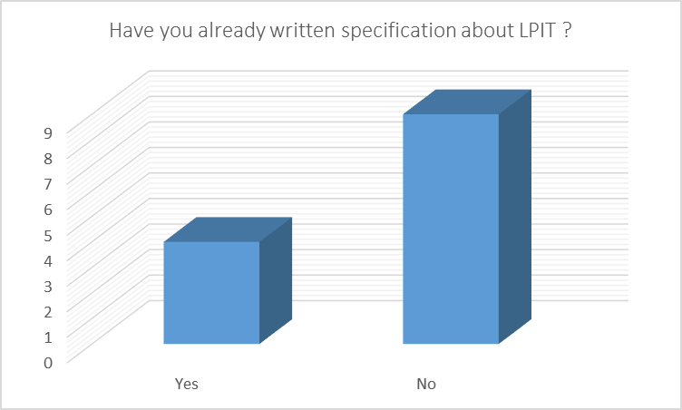

Q5.5 Does an early depreciation of HV equipment form a barrier to introducing the LPIT technology? How do you deal with this in the investment strategy?

The widespread replacement of conventional ITs by LPITs may lead to an early depreciation of HV equipment. Therefore, the goal of this question was to see if the balance between the early depreciation and benefits of using LPITs makes a good argument for the replacement of conventional ITs by LPITs.
Only 6 TSOs answered this question, and the results are varied: for two TSOs, an early depreciation is a barrier, whereas it is not a barrier for two others. For the last two, it depends on the valorisation of the benefits and the remaining life expectancy.
One TSO also noticed that introducing numerous electronic components is expected to reduce the lifetime of the IT, which should be taken into account.

Q5.6 In the following assumption, which ones do you consider as benefits for the use of LPITs? And why?

Acquisition cost | Most of the TSOs think that LPIT technology is more expensive than conventional ITs and therefore the acquisition cost is not a benefit. However some TSOs noticed that some aspects should be offset:  - The reconstruction of the secondary part and the further training of staff that can increase the global price;  - The reduced installation cost and a smaller footprint for LPITs.  Finally, one TSO analysed that there is no cost difference between LPIT technology and conventional one together with MU.
Lifetime cost | Almost all TSOs agreed that the lifetime cost is higher for LPITs than for conventional technology mainly because of the reduction of the lifetime expectancy.  Only one TSO indicated that no diagnostic will be required and therefore the lifetime cost could be smaller.
Environment | Almost all TSOs agreed there are huge environmental benefits of using LPITs. The most quoted benefits are no use of oil or gas (and no leakage), copper cable reduction and reduced use of cable trenches.  However, some TSOs indicated that the footprint due to bigger production (because of lower life time expectancy) could be higher and that place and material for construction (rare earths) should be taken into account for an environmental consideration.
Harmonics measure | Almost all TSOs agreed that LPITs offer a better solution for harmonics measurement due to the higher bandwidth than conventional ITs. However, harmonic measurements are not currently widely used.  Only one TSO indicated that the use of LPITs will lead to lower measurement quality.
Security and safety | Almost all TSOs agreed that LPITs offer more safety as they reduce the risk due to leakages (oil and gas), saturation, explosion, etc.  However, the cybersecurity risk seems to be higher.
Use of process bus | A process bus is needed when an LPIT is installed. The process bus has the benefit of reducing copper cable and is easier and faster to install. However, the engineering is more complex, rodents could cause more damage and it may be less secure from a cybersecurity point of view.
Other | Some other benefits were quoted :  - No danger of overexcitation during faults;  - No need for analog-to-digital converters that cannot be overloaded;  - It can be a common sensor for protection and measurement.  - Installation process is cheaper; and  - Lower weight.

Q5.7 In the previous question, which ones are the main drivers to make the transition towards LPIT?

The various answers show that the two main drivers are the safety issues and the environmental benefits of LPITs. Only one TSO stated that the acquisition cost is too high compared to the LPIT benefits. The use of LPITs can also cover new, which cannot be served with the conventional technology.

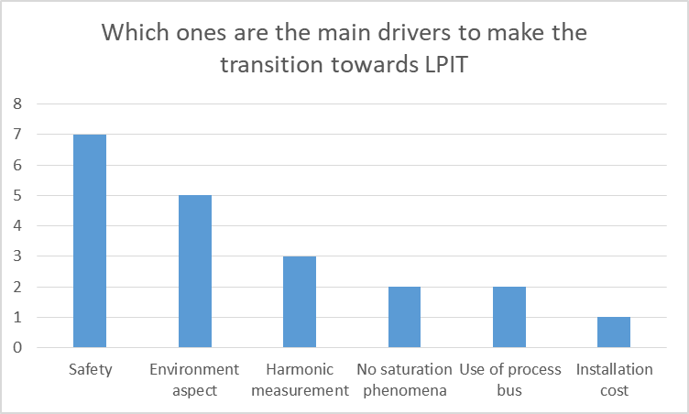

Q5.8 In the following assumptions, which ones do you consider as drawbacks for the use of LPITs? And why?

Technological readiness | Only one TSO thinks that the technology is mature.  The others indicated the following technological issues :  - Interoperability between different vendors;  - Accurate time synchronisation; and  - Not possible to use travelling wave with LPIT.
Supplier readiness | All TSOs think that the suppliers are not ready. Only a few suppliers are ready to offer this technology, and field experience is missing. Moreover, some pilots show that LPITs do not meet the market expectations
Cost | The cost seems to be one of the main drawbacks for the use of LPIT as it is considered much higher than the cost of conventional ITs. Moreover, the more frequent exchange of the equipment and the regular and frequent activities regarding IT/OT security must be included in the global cost.  Some TSOs hope that the cost will decrease in the future as the demand increases.
Writing the technical specification | A majority of TSOs do not consider that writing the technical specification has a drawback for the use of LPITs. Some TSOs have already written some.  However, others indicated a lack of knowledge, which makes writing a technical specification time consuming.
Availability of Standards | The standards for non-conventional ITs are not complete, and some topics must be clarified. For instance:  - Interoperability;  - Use of LPITs for commercial metering;  - The transient behavior of the LPITs; and  - Forward and backward compatibility of the MU.
Interoperability with protection and automation functions | The Interoperability with protection and automation functions is one of the main drawbacks as the use of LPITs implies having a process bus. Therefore, it could be a challenge to have protection algorithms using both conventional and non-conventional ITs (especially in the case of transients or fault situations). The different interpretation of the standards from different vendors and the lack of vendor independent configuration tools can also be an issue.
Regulatory problems | Regulatory frameworks are not established and fixed yet, especially for metering
Use for metering | The accreditation of a measuring chain using LPITs is not established yet in most of the countries. Therefore, it is not possible to use LPITs for metering.
Increased complexity | Almost all TSOs attest that the use of LPITs increase the complexity of the system. The number of components is massively increased, which leads to an increase of the risk of failure (and eventually a need for redundancy) and more complex testing schemes.  Therefore, the substation design must be carefully reviewed before introducing LPITS
Competence building | Almost all TSOs consider that competence building is not a drawback for the use of LPITs. Additional knowledge will be needed in different areas (specification, engineering, commissioning and testing and operation) but it should be achieved.
Other | Some other potential drawbacks were noted:  - Vendor dependency;  - Loss of flexibility as long as the interoperability; and interchangeability have not reached the satisfactory level.

Conclusion
The development of digitalisation has opened the door for alternative ITs. At the time of the questionnaire, most of the TSO do not have a pilot project with LPITs, therefore the LPIT vision described in this document can change following the first pilot results.
Nevertheless, some trends seem to be emerging:
LPITs present various advantages regarding the environmental aspect, harmonics measurement, security and safety, and saturation phenomena.
However, many TSO think that the suppliers are not ready, that the cost for LPITs can be higher than for conventional ITs and that the complexity will be higher with LPITs. Furthermore, the standardisation appears not to be ready.
Finally, regarding the lifetime of a conventional IT, it is likely that there will be at the same time an LPIT and conventional IT on the same substation. It will therefore be a challenge to have protections with algorithms using both conventional and non-conventional ITs.

