guidance on Project prioritisation and planning for EU implementation projects

ContexT

The preparation of this documents stems from discussions held in the Market European Stakeholder Committee (‘MESC’), a forum in which ACER, NRAs, NEMOs, TSOs, the EC and market participants take part. Considering the forthcoming challenges linked to the implementation of the single European electricity market, it has been decided to prepare a process which would allow to better consider the implementation constraints in the future allowing for a better long-term planning of such projects taking into account their overall impact on social welfare. This document is therefore the methodological deliverable of such decision.

Objective

This document lays down the framework for three interlinked processes. First, a new standard process to prioritise regulatory projects (Process 1). Second, two processes needed to improve the planning of regulatory projects: a process aiming at defining the delivery pace of those regulatory projects (Process 2) and then a clarification on the criteria to be considered for defining implementation deadlines of regulatory projects (Process 3).
Starting from observations more specific to the implementation of projects related to the CACM Regulation, the proposed processes however will encompass the regulatory projects of other regulations (EB Regulation, FCA Regulation, …).
This document has been drafted by ACER and NRAs, discussed, and aligned in the MESC framework. Though market participants would have desired the process to be run to assess priorities and possibly reset deadlines on the already congested pipeline of existing projects, they support the framework laid out in this document for future projects.

introduction – Why is a project prioritisation and planning framework needed?

Starting point: a list of implementation projects that is getting longer and longer

In the context of the implementation of the market codes (i.e. the Capacity Allocation and Congestion Management Regulation (‘CACM Regulation’), Forward Capacity Allocation Regulation (‘FCA Regulation’) and the Electricity Balancing Regulation (‘EB Regulation’), MESC members (hereafter referred to as ‘parties’) have observed that the implementation of the requirements set in EU-wide or regional methodologies was facing delays while the list of new project was getting longer and longer. In other words, the implementation pipeline of those requirements is facing congestions. This statement is valid for requirements linked to several market codes but is particularly noticeable for deliverables of the CACM Regulation. To implement those requirements, the regulated entities organise themselves around so-called projects. Parties observe that many project delays affect the delivery of the subsequent or interdependent projects, even across regulations (e.g. Core region ROSC-IDCC).

Proposed way forward

Following those observations stemming from the implementation of the market codes, parties propose significant improvements in the way timelines for implementation projects are defined and how project priorities are determined. This change will be applicable to all implementation projects stemming from market codes in case congestion is identified in a delivery pipeline (i.e. EB, FCA and CACM Regulations). Where relevant also, projects from other than the market codes (e.g. SO GL) should become considered in the future.
First, ACER and NRAs propose to better identify what would be a reasonable and feasible expectation for regulated entities to deliver regulatory projects in time (e.g. based on benchmarking of similar projects). This requires a discussion on parallelisation of projects and benchmarking of implementation time.
Regarding parallelisation of projects, it is not always reasonable to require all projects to be implemented in parallel and independently of each other, but it may be reasonable to require from the entities to improve the possibilities to parallelise the implementation of multiple projects, like any business identifying a bottleneck in their delivery pipelines. The prioritisation exercise does not have the ambition to open discussions on the financial or human resources that are allocated at national level, be it through cost recovery for NEMOs or tariff setting for TSOs, due to lack of legal basis to enable a coordinated approach at regional or European level. It is acknowledged that this may lead to a discrepancy between the expectations set in the prioritisation exercise and the actual ability to parallelise or to timely progress projects by some parties.
Regarding the legal deadlines for implementing each project, ACER and NRAs propose to set the legal implementation deadlines based on benchmarking (possibly with an external and independent support) to define how much time a specific project would require under an efficient organisation. Depending on the specificities of the considered project (e.g. the degree of novelty with regard to previously implemented ones), the benchmarking exercise will duly report on the assumptions that have been considered in estimating the corresponding legal deadline.
Second, beyond the need of parallelisation and benchmarking of implementation timelines, the congestions in project pipelines can still occur. Some clear prioritisation criteria therefore need to be defined ex ante in order to identify and prioritise the implementation of the most impacting projects in terms of social welfare (legal obligations, consumer benefits, …).
The above approach therefore aims to define the deadlines of regulatory projects under the assumption of an efficient organisation and based on clear priorities.
ACER and NRAs will continue their monitoring activities on implementation progress, investigate delays and NRAs should enforce when needed.

Objectives

The objectives for the introduction of this guidance are to:
  - Improve the way regulatory projects are planned (i.e. their regulatory deadline is defined) to better consider the ongoing implementations and current implementation capabilities
  - Allow for a better and more transparent long-term planning of regulatory projects, taking into account a number of key criteria
  - Involve stakeholders in the identification of implementation priorities
The objectives for the introduction of this guidance are not to:
  - Revise the existing legal or regulatory deadlines and challenge ongoing implementations
  - Consider new projects in or adding to the pipeline which are not mandated or necessary to implement projects mandated by regulatory or legal texts.

Definitions

Project delivery pipeline

ACER and NRAs consider that, in the scope of this framework, a project delivery pipeline is to be considered as an organisation of regulated entities aiming at delivering regulatory projects with a clear geographical scope in a relatively independent process from other delivery pipelines.
A regulatory project pipeline is defined by the following parameters:
- Regulation (e.g. CACM, EB and FCA)
- Geographic perimeter (e.g. EU-wide, regional, national)
- Applicability timeframe (e.g. SDAC and SIDC)
- Regulated entities (e.g. NEMOs, TSOs or joint)
- Project phases (e.g. R&D, Design or implementation)
An example of project pipeline can therefore be the CACM EU-wide SDAC NEMOs-TSOs implementation pipeline.
There can however be dependencies between regulatory projects pertaining to more than one project delivery pipelines.
Only project delivery pipelines facing congestion (i.e. that cannot deliver all planned regulatory projects in parallel) will be considered as part of this exercise.

Regulatory project

In the scope of this framework, ACER and NRAs consider that regulatory projects must respect the following characteristic: the project should be defined in a regulatory text, or part of discussions linked to a future or expected inclusion in a regulatory text (the regulatory texts are Regulations (EU) of the European Parliament and of the Council, Commission Regulation (EU) or binding decisions from ACER or NRAs).
If a congestion is identified in a pipeline delivering studies or performing research and development activities and considering its link with the implementation of regulatory projects, R&D initiatives can be considered as regulatory projects in the context of this framework.
To be part of a specific project pipeline, the project should impact this delivery pipeline and trigger work for at least 6 months in that specific pipeline (i.e. very small projects are out of scope). Projects can be part of more than one pipeline.
In the context of this framework, ACER and NRAs identify three distinct categories of projects:
- Regulatory projects with a clearly defined legal or regulatory deadline that is expected to be met,
- Regulatory projects with a clearly defined legal or regulatory deadline but for which the regulated entities have not been able to meet the deadline/are already certain that they will not be able to meet the deadline, and
- Regulatory projects without a clearly defined legal or regulatory deadline.
ACER and NRAs consider that the scope of the prioritisation exercise should cover all three categories of projects. However, the priority rating given to the project will serve a different purpose. Project categories 2 and 3 fall under the project prioritisation process either to provide guidance to regulated entities on the priorities of the project to be implemented (category 2) or to set a regulatory deadline (category 3), while considering how the timeline may be impacted by the projects of the category 1.
It is important to note that defining the priorities of projects falling under category 2 does not in any case relieve regulated entities from the obligations to implement those projects according to the legal or regulatory deadline nor NRAs to take enforcement measures.
Furthermore, ACER and NRAs distinguish the origin of the deadline of regulatory projects:
- Regulatory deadlines defined in a terms and conditions or methodology (‘TCM’) approved by ACER or NRAs, or
- Legal deadlines defined in a legal document not approved by ACER or NRAs (e.g. a Regulation (EU)).
ACER and NRAs consider that legal deadlines (category B) are not relevant for the scope of this exercise.

Overview of the different processes

Processes

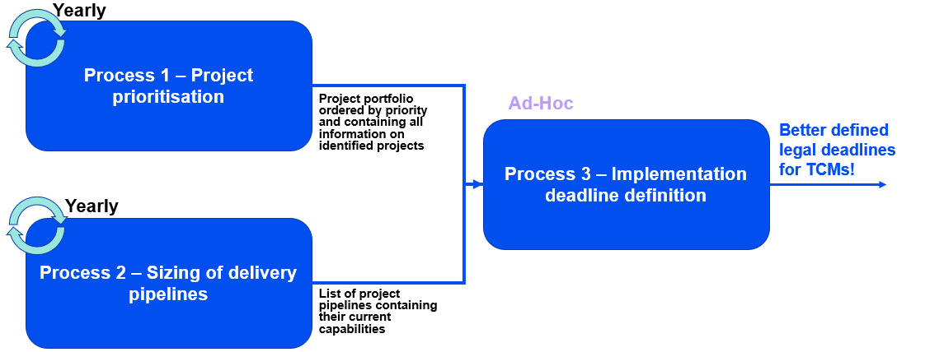

Timeline

Processes 1 and 2 are conducted every year in parallel and are totally independent to the implementation of projects.
The aim is to endorse the deliverables of year Y around June Y; these deliverables will then be presented in the subsequent CG and SCs. The whole process is expected to last approximately six months.

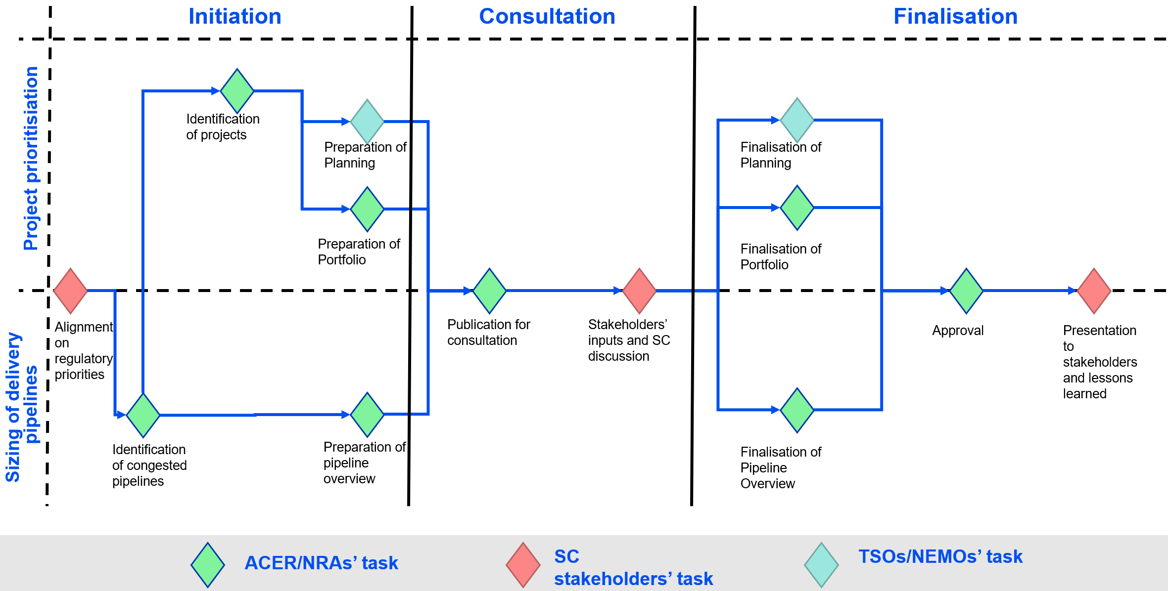

During the initiation phase, the SC stakeholders, in an ad-hoc session will identify the regulatory priorities. Following this alignment, ACER and NRAs are assigned the task to perform the prioritisation exercise for the year to come.

Governance

Three categories of stakeholders are involved in this prioritisation exercise:
- ACER and NRAs. Their role is to organize the prioritisation exercise and to produce the Regulatory Projects Portfolio and in a parallel stream, enforce when needed. A case handler is leading the process and can be supported by an expert team. External support regarding the estimation of design and implementation phases of the projects can be provided.
- Regulated entities (TSOs, NEMOs, JAO…). Their role is to provide input on the status of the ongoing projects, on the dependencies between the different projects, on the implementation efforts needed and on the priorities of the projects. They are in charge of preparing the Regulatory Project Planning.
- Market participants. Their role is to provide input on the priorities of the implementation projects.
This process will be on the agenda of the following meetings:
- ACER Electricity Working Group (‘AEWG’). This group endorses the project prioritisation deliverables and appoints the ACER/NRA case handler for this exercise.
- ACER Task Force (‘TF’). This group is in charge of preparing the project prioritisation deliverables. In case of a regional regulatory project pipeline, the relevant NRA organisation replaces the TF. In that situation, the TF serves as a reporting body.
- Coordination Group (‘CG’). This group is in charge of collecting the regulated entities input as well as to present the deliverables. In case of a regional regulatory project pipeline, the relevant CG organisation is in charge but the European CG serves as a reporting body.
- Stakeholder Committee (‘SC’). This group is in charge of collecting the market participants’ inputs as well as to present the deliverables. In case of a regional regulatory project pipeline, the relevant SC organisation is in charge but the European SC serves as a reporting body. It is expected that the MESC will be the primary SC body but in case this exercise extends to deliverables not linked to the market codes, it is possible that other SCs are involved.

Process 1 - Project prioritisation

This process has one main objective: allow for a continuous insight for all stakeholders on the regulatory projects portfolio and the priorities of the respective projects. The focus of this process is to define the priorities of the projects on a medium-term perspective (approx. from Y+2 to Y+5).

Deliverables

The outcome of the project prioritisation exercise is first to produce a project portfolio (‘the Regulatory Projects Portfolio’). In the form of an excel sheet, the Regulatory Projects Portfolio contains (at least) the following information on the different implementation projects:
- Brief description of the regulatory project
- Regulatory implementation deadline of the regulatory project (to be defined, implementation deadline, legal text in which the deadline is defined)
- Implementation status of the regulatory project (to be started, design phase, implementation phase)
- Project pipeline (e.g. CACM SDAC/SIDC, CACM NEMOs/TSOs/joint, EB TSOs, FCA TSOs)
- Project priority (qualitative rating, see section 6.4)
- Interactions/dependencies with other implementation projects (depends on X, blocks project X, …)
The regulatory projects are ordered in the Regulatory Projects Portfolio according first to their implementation status and second to their project priority.
This exercise should also deliver a planning (‘the Regulatory Project Planning’) in a powerpoint format detailing over the next 5 years the different projects to be implemented, highlighting the design and implementation phases. Regulated entities (see section 6.2) are in charge of preparing this deliverable. The Regulatory Project Planning contains planning for all the different pipelines under this framework.

Detailed timeline

Three distinct phases can be identified:
- The initiation phase during which
  - the SC identifies the regulatory priorities for the years to come
  - the ACER TF(s), in coordination with the relevant regional groups, identifies the relevant regulatory projects to be considered as part of the exercise and consult the list with the relevant regulated entities
  - the ACER TF(s), in coordination with the relevant regional groups, prepares a first version of the Regulatory Project Portfolio for consultation
  - Regulated entities prepare a first version of the Regulatory Project Planning
- The consultation phase during which stakeholders will provide input on the portfolio proposed by the TF(s) through an ACER targeted consultation of the MESC members of at least 4 weeks and a discussion in the relevant CG and SC meetings (+ ad-hoc meetings if relevant)
- The finalisation phase during which the TF(s) will consolidate the received inputs into an updated Regulatory Projects Portfolio. The regulated entities also consolidate the inputs into an updated Regulatory Project Planning. The portfolios of the different TF(s) are then merged and submitted to the November AEWG for endorsement. The deliverables are presented in the CG and SC. Responses to the public consultation as well as feedback to those responses will be made public, lessons learned of the process as well.

Criteria

Based on the objectives defined in Regulation (EU) 2019/943 (‘Electricity Regulation’) Article 59(4), prioritisation criteria can be defined, in order to build a qualitative project priority rating. The proposed criteria are the following:
- Overall efficiency
- Effectiveness to enhance market integration
- Effectiveness to ensure non-discrimination
- Effectiveness to increase competition
- Effectiveness to enhance the efficient functioning of the market
These criteria can be declined in a concrete set of parameters to be assessed. The proposed list of parameters can be found below.
- Overall efficiency
  - Overall benefits compared to costs for all stakeholders and impact on assets and implementation efforts
  - Market consensus

- Effectiveness to enhance market integration
  - Allows the inclusion of new bidding zones/ bidding zone borders
  - Allows for harmonisation of rules or processes (either across timeframes/regions)
  - Coherence with principles/functioning of the EU policies in general (such as decarbonization, SoS, etc.) and other timeframes/regions/markets

- Effectiveness to ensure non-discrimination
  - Allows to treat all players equally, if the circumstances are equal
  - Removes discriminating rule

- Effectiveness to increase competition
  - Allows for competition between new borders/bids of market participants
  - Removes entry/exit barriers

- Effectiveness to enhance the efficient functioning of the market
  - Improves price signals
  - Improves welfare
  - Improves operational stability

Prioritisation score

The scoring follows a simple process
- Assign a rating in function of the number of positive or negative identified parameters [-2, +2] (e.g. a project will get a +2 rating for the “Effectiveness to enhance market integration criteria because it allows the inclusion of new bidding zones/ bidding zone borders, allows for harmonisation of rules or processes (either across timeframes/regions) and is coherent with rules of other timeframes/regions.)
- Compute an average score as follows:
  - Final score = 2/3*(1/4 * ( Σ Score(Objectives 1-4)))+1/3*Score(Objective 5)
- The following rule is then used to qualitatively rate the different project priorities:
  - Final score >=1.5 = Very high
  - >=1 = High
  - >=0.5 = Medium
  - >=0 = Low
  - <0 = Consider discarding
  - Projects with a deadline fixed in EU regulation or international treaties (e.g. UK-EU MRLVC) are evaluated but get a « Non-relevant » score considering that ACER and NRAs have no competence to challenge their implementation

Process 2 – sizing of the delivery pipelines

This process has two main objectives: identify the relevant delivery pipelines for the prioritisation exercise and evaluate their capabilities in terms of deliveries (i.e. how many projects can be delivered in parallel).

Deliverables

The outcome of this exercise is to deliver an excel sheet containing the list of regulatory project pipelines to be considered for the prioritisation exercise as well as an estimation of their capabilities (‘Overview of Regulatory Project Pipelines’). This list is based on the observations from ACER/NRAs of the project pipelines facing congestion.
The capabilities of each regulatory project pipeline are measured in its ability to deliver a certain number of projects in parallel, as a single integer. There is no unit of this measure.

Detailed timeline

Three distinct phases can be identified:
- The initiation phase during which
  - the SC identifies the regulatory priorities for the years to come
  - the TF(s) identifies the relevant regulatory project pipelines to be considered as part of the exercise
  - the TF(s) prepares a first version of the Overview of Regulatory Project Pipelines’ for consultation
- The consultation phase during which stakeholders will provide input on the deliverable proposed by the TF(s) through an ACER public consultation of at least 6 weeks and a discussion in the relevant CG and SC meetings (+ ad-hoc meetings if relevant)
- The finalisation phase during which the TF will consolidate the received inputs into an updated Overview of Regulatory Project Pipelines. The deliverables of the different TF(s) are then merged and submitted to the AEWG for endorsement. The deliverables are presented in the CG and SC.
Recommendations from ACER and NRAs to NEMOs and TSOs to further develop/improve the size of the delivery pipelines can accompany the outcome of this exercise. For example, ACER and NRAs could conclude this exercise by issuing a letter, mentioning that as of a certain date, ACER and NRAs will define implementation deadline based on updated assumptions on the size of the delivery pipeline.

Criterion

The TF’s decision is fully based on a single criterion: the ability for regulatory project pipelines to deliver in parallel all the regulatory projects that are identified. In case the answer is positive, the regulatory project pipelines do not need to be considered. In case the answer is negative, they need to be considered.

process 3 - Implementation deadline definition

This process defines how the input of Processes 1 and 2 feed into the existing process of defining a legal deadline as part of the decision-making processes for adopting TCMs.
To define the implementation deadline of a regulatory project, several criteria need to be considered:
- Estimated duration of design and implementation of a regulatory project (see section 8.1 below)
- Status of the impacted delivery pipelines
- Position in the Regulatory Projects Portfolio
This process is to be conducted every time the legal deadline of an implementation project is to be defined.
Similarly to the project prioritisation process, ACER and NRAs decide on the final outcome of the exercise. A public consultation is organised, allowing stakeholders to provide their views, this time through the usual decision-making processes.

Estimation

Following a submission of the terms and conditions or methodologies, ACER/NRAs (depending on the geographical scope of the TCM will proceed to the estimation of the duration of the implementation of implementation projects. To perform this exercise, ACER/NRAs will proceed to a benchmarking of similar implementation projects. This benchmarking can be done either based on the implementation period of similar historical implementation projects or on projects of other industries/sector. This exercise can be supported by an external consultant.

In the text, references to ‘pipeline’, ‘project pipeline’ are to be understood as references to project delivery pipelines.
For example, a regional capacity calculation implementation can be considered as independent from the pan-European capacity allocation.
In the text, all references to ‘projects’ are to be understood as references to implementation projects.
such as request for changes described in the Algorithm Methodology Article 14(1)(a))
Following lessons learned from a project prioritisation process, a deviation from a weighted average computation is possible.

